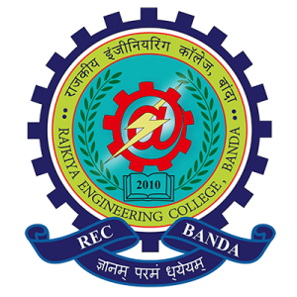

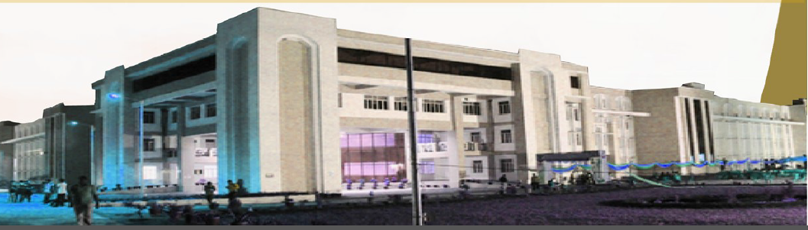

**CONTENTS**

|  |  |  |
| --- | --- | --- |
| **S.No.** | **Particulars** | **Page No.** |
| 1. | Foreword by Director | 3 |
| 2. | About the Institute | 4-5 |
|  | Institute’s Vision and Mission | 6 |
| 3. | Governance structure/ Organization structure | 7-9 |
| 4. | Academic calendar | 10 |
| 5. | Infrastructure: Academic, Library, Computer Centre, Residential, Hostels | 11-12 |
| 6. | Department’s profile with infrastructure & facilities | 13-29 |
| 7. | Programmes offered (UG, PG, PhD) | 30 |
| 8. | Students strength (UG, PG, PhD): Sanctioned Intake & Actual Intake), category and gender wise | 31-35 |
| 9. | Exam result analysis | 38 |
| 10. | Transition rate of 1st year UG students | 39-40 |
| 11. | GATE qualified students data | 41 |
| 12. | Training programmes /Internship for students | 42-44 |
| 13. | Training programmes held for teachers & staff | 45-46 |
| 14. | Campus placement data | 47 |
| 15. | Candidate completed/doing PhD | 48 |
| 16. | Start-ups and Innovations | 49 |
| 17. | Curricular achievement & Co-curricular achievement | 50 |
| 18. | Extra-curricular activities | 51 |
| 19. | Financial information: Funds Received & Spent | 52-53 |

**FOREWORD BY THE DIRECTOR**



Director, Rajkiya Engineering College Banda

Rajkiya Engineering College Banda is on a fascinating path of growth and development. It has already established itself as one of the top technological institutions in Uttar Pradesh, but that is just the tip of the iceberg, as compared to the huge progress the institute is making. We are advancing the institute’s tradition of excellence in Engineering and Technology Education through high-quality programs in teaching, research, on-site industry executive training, and service. We are fortunate to have a talented, highly committed teaching and support staff to ensure the best learning environment as possible.

Our faculties are renowned scholars and accomplished practitioners who are actively engaged in the academic excellence and in innovative research ideas of the modern world. Eachcollaboration is not an additional feather in our cap but an integral part of our growth strategy. We have made a stunning beginning, and there is a long way to go, but I am sure with the active cooperation of all our stakeholders, students, faculty, staff, employees, collaborators, parents of the students, governmental organizations, media and public at large, we will be able to fulfill the motto of REC Banda.

**About the Institute**

Rajkiya Engineering College Banda formerly known as Dr. Bhim Rao Ambedkar Engineering College of Information Technology was established by the Government of Uttar Pradesh in the year 2010 with three branches, Electrical Engineering, Mechanical Engineering, and Information Technology with an annual intake of Sixty (60) in each branch. The college is an affiliated institute of Dr. A P J Abdul Kalam Technical University, Lucknow (Formerly Uttar Pradesh Technical University, Lucknow). Since its inception it was running in the campus of BIET, Jhansi. In July 2015 it moved to its own fully residential campus located at Atarra, Banda.

All necessary State-of-the-art infrastructures as per the norms of AICTE have been developed at the institute to enable the millennials to dawn the role of future leaders, managers, researchers and productive team players in the field of science and technology.The institute intends to ensure holistic growth of students in order to make them accountable for societal and national elevation and amelioration. All offices are fully equipped with electronic infrastructure required for communication and reprographic facilities at par with any other institute of national importance.

The teaching and learning take place in various fully air-conditioned Smart Class Rooms (SCRs) equipped with modern teaching aid, such as Touch Screen Podium, Interactive White Boards, Short Throw Projector along with Audio Visual facilities. The college also has 500 KVA generator unit capable of providing electricity to the whole campus including academic building, workshop, hostels, street lights, etc.

The qualified and experienced thirty-six outstanding faculty members, latest equipment, Hi-end computers, teaching-aids, multimedia, wi-fi connectivity required for modern-day teaching create an edge over other engineering institutes. The hostels, the common room equipped with fitness equipment, Student Activity Centre (SAC), canteen, grocery store, a guest house, the infirmary conjure up a spell of being the most ideal campus.

The institute has been selected under TEQIP-III project. Under this project, the college received a grant of Rs.10 Crore from 2017 to 2020. The objective of TEQIP-III is to improve the quality and equity in engineering institutions in focus states. Other objectives include system-level initiatives to strengthen sector governance and performance to improve the policy, academic, and management practices of the college. Under DDQIP scheme the institute has also been granted Rs.10.00 crore on 5 August 2017 for three years.



To impart quality education in various fields of engineering and technology to develop the Institute into a centre of academic excellence.



To develop the students as proficient technocrats who are professionally skilled andsocially accountable through quality education by providing the state-of-the-art infrastructure and environment.

**Governance /Organization Structure**

**Organization Structure of REC-Banda**

1. **Academic And Administrative**
2. Director
3. **Academic**
4. Professor including Professor, Training and Placement.
5. Associate Professor, if any,
6. Assistant Professor
7. Workshop Superintendent
8. Assistant Workshop Superintendent
9. Teaching/ Research Assistant
10. Such other academic staff as may be decided by the board.
11. **Teaching Supporting**
12. Computer system Manager
13. Computer Programmer
14. Junior Computer Programmer and Network Engineer
15. Technical Assistant
16. Demonstrators
17. Workshop Instructors/Instructors
18. Computer Operators
19. Computer Data Operators
20. **Technical**
21. Foreman
22. Supervisor (Workshop)
23. Mechanics Grade-A
24. Horticulture Assistant, if any
25. Draftsman and
26. Such other technical staff as may be decided by the board.
27. **Administrative (Non-Teaching)**
28. Registrar
29. Deputy Registrar
30. Assistant Registrar/Head Assistant
31. Accounts Officer
32. Audit Officers, if any
33. Stores or Purchase Officer, if any
34. Estate Officer, if any
35. Medical Officer (Male/Female), if any
36. Engineer (Executive/ Assistant)
37. Librarian
38. Deputy Librarian, if any
39. Assistant Librarian, if any
40. Physical Training Instructor, if any
41. Such other administrative Staff as may be decided by the board.

**Board of Governers @ REC- Banda**

The Board shall be composed of:

|  |  |  |
| --- | --- | --- |
| (i) | Academician/Industrialist nominated by Government of U.P. | **Chairman** |
| (ii) | Principal Secretary/ Secretary, Technical Education Deptt. U.P. | **Vice-Chairman** |
| (iii) | Secretary, Finance Deptt, U.P. or his nominee, not below the rank of Joint Secretary. | **Member** |
| (iv) | Vice-Chancellor of the University, to which the College/Institute is affiliated. | **Member** |
| (v) | Director, Indian Institute of Technology, Kanpur. | **Member** |
| (vi) | Director, Indian Institute of Technology, (BHU), Varanasi. | **Member** |
| (vii) | Director, Directorate of Technical Education, Uttar Pradesh Kanpur. | **Member** |
| (viii) | A Nominee of the All India Council of Technical Education. | **Member** |
| (ix) | One eminent technologist/ engineer having specialization in thefield advent to the Institute to be nominated by the Board. | **Member** |
| (x) | One Head of the Department of the Institute/ Institution not belowthe rank of Professor to be nominated by the Board for one year by rotation in order of seniority. | **Member** |
| (xi) | There eminent persons in the field of Technical Education to be nominated by the State Government. | **Member** |
| (xii) | One eminent person from industry to be nominated by the State Govt. | **Member** |
| (xiii) | One person from S.C. category to be nominated by the Chairman Governing body from amongst reputed teachers/ educationist/ Industrialist. | **Member** |
| (xiv) | One person from O.B.C. category to be nominated by the Chairman Governing body from amongst reputed Teachers/ Educationist/ Industrialist. | **Member** |
| (xv) | Director/ Principal of the Institute/ College. | **Member Secretary** |

**Academic Calendar**



**Infrastructure**

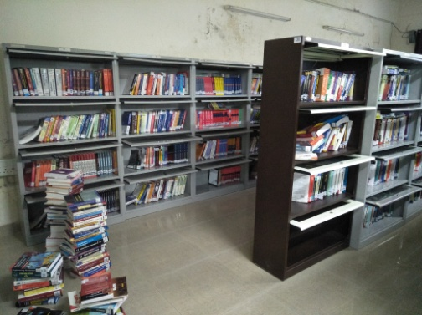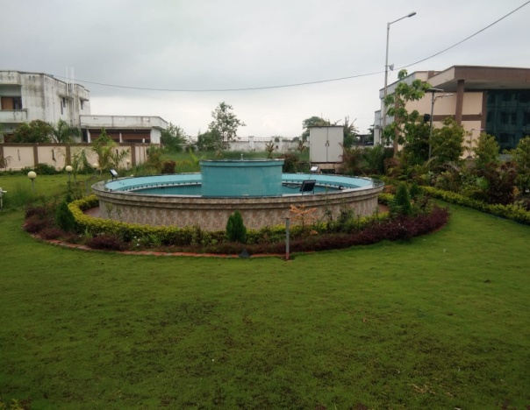REC’s Awe-inspiring infrastructure provides the students with an excellent environment to pursue their academic passion and for outstanding academic delivery. The lush green campus is dotted with hi-tech laboratories and modern buildings. The campus offers a fusion of environment, resources and support to maximize the quality of the student learning experience.

**Library**: There are more than 5000 books, magazines and journals in library.Book bank facility is also provided to students. The students and faculty can access more than 400 international journals and periodicals

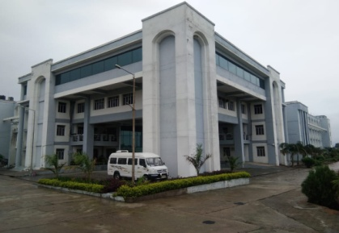

**Academic Building:**

Ground Floor: Mechanical Engineering Department.

First Floor: Electrical Engineering Department.

Second Floor: Information Technology Department.

Third Floor: Applied Sciences & Humanities Department

**Hostels:**

1. Aryabhatta Hostel: Triple seated 69 rooms
2. Ramanujam Hostel: Triple seated69 rooms
3. C. V. Raman Hostel: Triple seated69 rooms
4. Mandakini Hostel: Triple seated69 rooms
5. Transit Hostel: Triple seated69 rooms

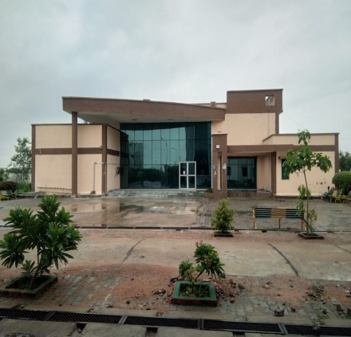

**Student Activity Centre:**It has a hall for Table Tennis and four rooms for Gymnasium and playing carom.

**Residence:**

1. Type V- 1 Number
2. Type IV- 4 Numbers
3. Type II- 24 Numbers (Under Construction)
4. Type I- 4 Numbers

|  |  |
| --- | --- |
| C:\Users\user-03\Desktop\74541239-91bc-4048-be7a-f8b6734a24d3.jpg | C:\Users\user-03\Desktop\b5da4e53-6484-44bf-8232-805ff39a3218.jpg |
|  |  |

**Department’s Profile with Infra Structure and Facilities**

#### 

#### About the Department

The Department offers Bachelor of Technology programme in Information Technology. The faculty and staff members of Department are well qualified and efficient in guiding the students in every field of the Information Technology. The area of Information Technology aims at design, implementation and management of computer-based information systems. These automated information systems are capable of storing, transmitting and retrieving of all types of complex data. The Department develops IT Graduates having good problem-solving capabilities, communication skills and habit to learn new technologies. Apart from prescribed university curriculum, focus is on practical and skill-based training to ensure that students grow according to changing market scenario. Opportunity comes someone’s way when one is technically well versed and gets fully empowered through varied exposures.  The engineering graduates of Information Technology from REC by utilizing the following platforms become job fit and get opportunities as IT Professionals, Entrepreneurs, Researchers, Innovators and Academic Administrators. Department curriculum activities related to the field are:

* Industrial Visit/ Internship Program
* Training Programs/ Workshops
* Personality Development Program (PDP)
* Centers of Excellences & Innovations
* National Level Project Competition

#### Vision

The Information Technology Department of Rajkiya Engineering College, Banda would continue to provide leading program in the field of computing. The graduates produced would be globally recognized as innovative and well prepare computing professionals. These graduates would be leaders and innovators in the industry, education and other walks of social life.

#### Mission

* To impart quality engineering education, enhance problem solving skills, foster research and innovation, encourage entrepreneurship and mold students of integrity and ethics to provide leadership with social sensitivity for the betterment of the country and humanity as a whole.
* To provide a learning environment that helps students to be successful in their professional lives and to prepare student to be lifelong learners by offering a solid theatrical foundation in computing along with applied computing experiences and educated them about their professional, and ethical responsibilities.
* To have high quality faculty and staff with an appropriate know how and degrees with a commitment to remain professionally advanced through ongoing research and professional development program.

#### Laboratories

The labs are equipped with a 100 mbps switched network with a star topology. The lab is connected to the campus network through a router and fibre optic cable. The Department has following computer lab facilities:

#### Computer Lab: Computer Centre

It is a general observation that students at the entry level of undergraduate programs face some difficulties to understand about the course.   
 This lab provide practical exposure and on-hand working environment to such students, The computer Center has over 60 computer made available in central air conditioned laboratory of the college building. They are fully networked with branded HP (i3) systems and server with one Laser Printer. High internet speed of 100 Mbps, broadband internet connectivity has been provided in main computer center with at least one faculty and technical staff to guide them.



#### The Hardware Specification of Available computers:

* Intel i3 5th generation x64 Processor
* 1 TB Hard Disk
* 4 GB RAM
* An integrated Cabinet with speakers and other accessories.

***Software Specification:***

* Code Block, Dev CPP, Turbo C++.
* JDK latest version.
* MATLAB
* Net beans

***Subject practice:***

* Programming Lab

* Algorithms Lab

* Operating Systems Lab

* Data Structure Lab

* Design and analysis of algorithm Lab

***Computer Lab 1:***

This LAB is for design and implementation of various computer applications. In this LAB students work on new Technologies and expert in contemporary technologies like Database Management services and Web designing. The Lab is fully centralized air conditioned and well furnished. This Lab consists of one server and 30 computers with one printer. Lab is equipped with a wall mount projector.

#### The Hardware Specification of Available computers:

* Intel i3 5th generation x64 Processor
* 1 TB Hard Disk
* 4 GB RAM
* An integrated Cabinet with speakers and other accessories.

#### Software Specification:

* + Post GRE SQL
  + PHP server (XAMP Server)
  + MYSQL
  + Microsoft SQL Server

***Subject practice:***

* Database Management Systems Lab

* Software Project Work Lab

#### Computer Lab 2:

The Department has a well-equipped, fully centralized air conditioned, well-furnished Project Lab. This LAB consists of 30 Machines and a smart Board to full fill the presentation needs.

#### Computer Specification:

* i3 5th generation x64 Processor
* 1 TB Hard Disk
* 4 GB RAM
* An integrated Cabinet with speakers and other accessories.

#### Software:

* Linux OS
* MATLAB
* Anaconda Navigator
* R Studio
* Android Studio
* NS-2
* ArgoUML, UML Umbrello

***Subject practice:***

* Project Lab

**\*** Software Engineering Lab

* Object Oriented Techniques Lab

#### Computer Lab 3: CAD Laboratory

The CAD Laboratory is a central facility of the institute where all undergraduate students, and faculty members- can work with the sophisticated 2-D & 3-D design and analysis software. They can learn to use the latest software and carry out their research work. The CAD Laboratory has a total number of 30 computers with the latest configurations connected with a high-end server through switched networking.

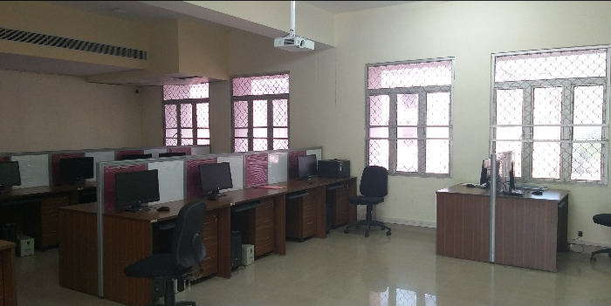

#### Computer Specification:

* i3 5th generation x64 Processor
* 1 TB Hard Disk
* 4 GB RAM
* An integrated Cabinet with speakers and other accessories.

**The Software available in the CAD Lab:**

* + AutoCAD
  + ANSYS -11
  + Fusion 360

**Subject practice:**

* Mechanical Department Labs

#### Computer Lab 4: Simulation Lab

In this LAB we simulate various electrical as well as electronic circuits. For simulation, we use various tools like MATLAB and ANSYS. In this LAB use MATLAB software for interpret different problems related to equations and related computational tasks.

#### Computer Specification:

* i3 5th generation x64 Processor
* 1 TB Hard Disk
* 4 GB RAM
* An integrated Cabinet with speakers and other accessories.

**The Software available in the CAD Lab:**

* + MATLAB
  + ANSYS -11

Subject Practice:

### **\* Switching Theory and Logic Design**

#### Computer Lab 5:

This High performance Computing Lab consists of 30 computers in which latest and required software are installed on the computers.

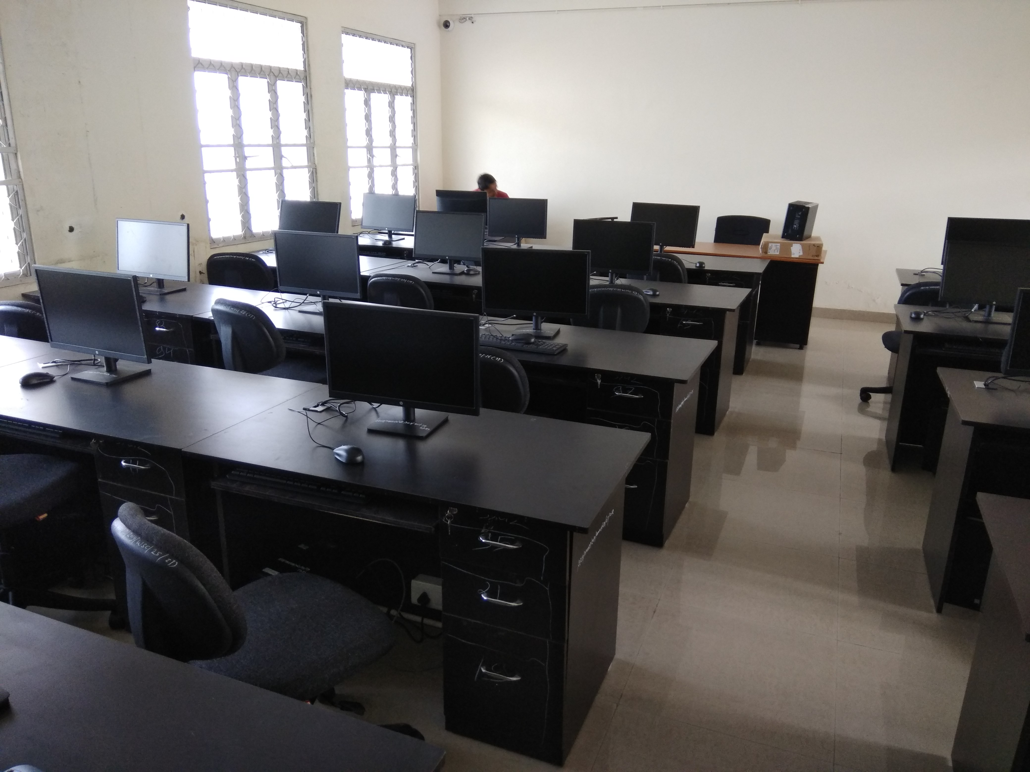

#### Computer Specification:

* I5 8th generation, 64 bit OS,
* x64 Based Processor
* 1 TB Hard Disk
* 8 GB RAM
* An integrated Cabinet with speakers and other accessories.

#### Software:

* Anaconda Navigator
* R Studio
* Android Studio
* NS-2
* Anaconda Navigator

***Subject practice:***

* Artificial Intelligence Lab

* Computer Network & Information Security Lab

* Compiler and Automata Lab

* Data Mining Lab

#### Computer Lab 6:

This Web Application Development Lab consists of 30 computers with higher configuration. In this Lab, students perform experiments related to web technology. This lab consists of latest and advance software for Web applications.



#### Computer Specification:

* I5 8th generation, 64 bit OS,
* x64 Based Processor
* 1 TB Hard Disk
* 8 GB RAM
* An integrated Cabinet with speakers and other accessories.

#### Software:

* Atom IDE
* Notepad++

***Subject practice:***

* Web Designing Lab

* Web Technology Lab

#### Additional Infrastructure

#### Server Room

* Department has one server room which is full with different kind of servers. Their configurations are: Windows server 2012 R2, Intel Xeon processor, 9 TB HDD, 64 GB RAM.
* Server 1 (Mechanical department): The following software are installed.
  + ANSYS 15
  + IIS, Xamp Server
  + Solid Works
* Server 2 (Electrical department): Software MATLAB is installed
* Server 3 (Information Technology): The following software are installed.
  + Orell language software
  + UTP Plus for Video Conferencing
  + Xamp Server
  + IIS
  + FTP Server
* Server 4 (Information Technology): College ERP is configured.
* Apart from this NPTEL Lecture series are also uploaded in servers.
* The server room also contains two LCDs which display the footages of approximate 200 cameras.

#### Online UPS/Battery Backup

An array of 80 uninterruptible power supply, UPS or battery/flywheel backup, is maintained in our college that provides emergency power to a load when the input power source, typically mains power, fails.

This panel of UPSs used to protect hardware such as computers, data centers, telecommunication equipment or other electrical equipment where an unexpected power disruption could cause injuries, fatalities, serious business disruption or data loss. The labs are fully air conditioned with UPS protection against power outages.

#### 

#### About the Department

The Department of Electrical Engineering at Rajkiya Engineering college Banda offers a vibrant environment for undergraduate education in Electrical Engineering. The department has well established laboratories for Power System, Electrical Machines, Power Electronics & Drive, Digital Electronics, control, Instrumentation, Communication system and Microprocessor.

The Department has well qualified faculty, most of them have their Master and Ph.D degree from IITs, NITs, Central & State Technical Universities.

The Department of Electrical Engineering at Rajkiya Engineering college Banda was started in the year 2010. Department offers B. Tech (Electrical Engineering) with a yearly intake of 60 students. There is a provision of 12 lateral entry admissions in to second year on Diploma/B.Sc. basis. The department has grown not only in terms of student and faculty strength, but also in improving the laboratory facilities for the teaching and research purposes. Thus, the department has dedicated and state of the art teaching / research laboratories. The department is recognized for excellence in research, teaching and service to the profession. The faculty members have strong sense of responsibility to provide the finest possible education for undergraduate students.

#### Vision

1. To impart quality education in various fields of engineering and technology to develop the Institute into a centre of academic excellence.
2. To be a centre of excellence in Electrical Energy Systems.

#### Mission

1. To deliver quality education in emerging fields of Electrical Engineering to empower the students to meet Industry standards.
2. To enrich with the latest developments through seminars, expert lectures, workshops, industrial visits, and industrial training.
3. Ethical and value education by promoting activities addressing the societal needs.

#### Laboratories

The Department has Seventeen following laboratories:





**Basic Electrical Engineering lab**

Basic Electrical Engineering Laboratory is used with the institute all course Electrical Engineering, Mechanical Engineering, Information Technology. This lab can accommodate about 60 students in a semester. The experiments are designed to expose students to the practical executions of the fundamental theories of Electrical Engineering.

**Network Lab**

The objective of the Network lab is to expose the students to electrical circuits and give them experimental skill. The purpose of lab experiment is to continue to build circuit construction skills using different circuit element. It also aims to introduce MATLAB a circuit simulation software tool. It enables the students to gain sufficient knowledge on the programming and simulation of Electrical circuits. On the completion of Electrical Circuit and simulation practical course, the student will be able to attain the following:

1 Familiarity with DC and AC circuit analysis techniques.

2 Analyze complicated circuits using different network theorems.

3 Acquire skills of using MATLAB software for electrical circuit studies.

4 Determine the self and mutual inductance of coupled coils.

**Power Systems Lab**

This laboratory is designed to give students hands-on experience on different equipment of electrical power system. This is an advanced laboratory to carry out modeling, simulation and analysis of power system equipments. Students can practically verify several concepts and procedures learned in power system modeling and analysis.

**Electromechanical Energy Conversion Lab-I**

The objective of the this Laboratory is to impart knowledge about characteristics and behavior of the DC Machines, operation of transformers, operation of DC machines and give them experimental skill, familiarize with the constructional details of different types, working principle and their performance. It also provides the essential facilities to the students to augment their concepts about the fundamentals of rotating machines. It is well equipped lab to provide experimental and hands-on experience to the detailed study of characteristic and operational aspects of DC electrical machines.

**Electromechanical Energy Conversion Lab-II**

This laboratory is designed for students to perform experiments on Induction motors and Synchronous machines. The main objective of this laboratory is to impart knowledge about characteristics and behavior of the AC Machine, synchronous and asynchronous machines and give them experimental skill, familiarize with the constructional details of different types, working principle and their performance. This lab consists of machines and all are mounted in industrial type of assembly to give the students industrial feel. Well established with all kinds of motors and variable frequency drives (VFDs). The lab has moderate machines and students are using for project and research work also.

**Electrical Instrumentation Lab**

The motto of this Laboratory is to reinforce the students with an adequate work experience in the measurement of different quantities and also to expertise in handling the instruments involved. The basic operations of sensors and the process where it might be used, practically realized in the laboratory. It also provides facilities to train the students in the measurement of displacement, resistance, inductance, torque and angle etc., and to give exposure to AC, DC bridges and transient measurement.

**Electrical Measurement Lab**

The aim of this is different electrical and electronic parameters such as voltage, current, power, energy, resistance, inductance, capacitance etc. are performed in Electrical Measurement laboratory. Also to understand the constructional features of different indicating type instruments like PMMC, MI, Electro-dynamometer etc. are described in the instrument workshop. In addition to the measurement, calibration of instruments such as ammeter, voltmeter, wattmeter etc. are performed in this laboratory. Measurement of current and voltage using instrument transformer is an important feature of this laboratory.

**Power Electronics lab**

The aim of the Power Electronics laboratory is to study the characteristics of switching devices and its applications in rectifiers, AC voltage controllers, inverter and choppers. It also acquaint with the application of electronic devices for conversion, control and conditioning of electric power. Further it aids the students to acquire an overview of different types of power semiconductor devices and to cognize the operation, characteristics and performance parameters of controlled rectifiers. The principle of operation, switching techniques, modulation techniques and harmonic reduction techniques in PWM inverters are studied in the lab.  It also provides experience with common components such as motors, batteries and power semiconductors. The lab facilitates faculty and students who are conducting research, industry sponsored projects in power converters in particular and electrical energy conversion in general.

**Numerical Technique Lab**

The aim of this lab is to reinforce the students with MATLAB, linear equation, basic matrix operation, time response of R-L-C circuits.

**Electrical Drives Lab**

The first-hand knowledge in electrical circuits, AC & DC Machines and Drives is acquired. The lab is equipped with various motors along with their drives and measuring instruments. The characteristics of motors and generators are studied practically.

**PLC Lab**

The primary objective of the Programmable Logic Controller lab is to familiarize students with how signals from input devices (i.e. switches, sensors, etc.) can interface with PLC units in order to invoke certain actions (i.e. start/stop an electric motor, turn on a light, etc.). A PLC functions similar to your computer. A computer processes input (i.e. keyboard entries, sounds from microphones, etc.) and invokes a certain output (i.e. showing the letter you typed on the screen, sending a request through the internet, etc.). Similarly, a PLC unit processes input and invokes output, but the inputs to a PLC unit are usually devices such as sensors, buttons, switches, etc. The outputs are usually signaling to start/stop motors, turn on/off lights, sound a horn, etc.

**PROJECT LAB**

This Lab has provided a platform for students and research associates to implement research based projects under the guidance of faculty members. The facility has been utilized by B.Tech students extensively for their project and research work. The outcome of the project has resulted in publications in various journals and conference proceedings (both at national and international level). The centre has provided a learning platform for both students and faculty.

**Control System Lab**

The objective of the Control System laboratory is to provide sound knowledge in the basic concepts of linear control theory and design of control systems, to understand the methods of representation of systems and getting their transfer function models. It facilitates basic knowledge in obtaining the open loop and closed loop responses to understand the concept of stability of control systems. It also helps the students to study the compensation design for a system. It also aims to introduce MATLAB a control simulation software tool.

**Switchgear & protection lab**

The objective of this lab is to make students familiar with the working of various switchgear equipment like under and over voltage relay, reverse power relay and used for power system protection and performance of these equipments.

**Electronics Lab**

The aim of this lab is to Design and test rectifiers, clipping circuits, clamping circuits and voltage regulators, Compute the parameters from the characteristics of JFET and MOSFET devices, Design, test and evaluate BJT amplifiers in CE configuration, Design and test JFET/MOSFET amplifiers, Design and test a power amplifier, Design and test various types of oscillators.

**Communication Technology Lab**

The objective of this lab is to understand basic theories of digital and analog communication, to design and implement analog/ digital modulator and demodulator and to understand the applications of balanced modulator circuit.

**Microprocessor Lab**

Microprocessor Laboratory aims to produce graduates who have understood the basic operation of microprocessor system along with fundamental programming skills in assembly language. This laboratory houses the hardware which includes 8085 Microprocessor trainer kits, 8086 Microprocessor trainer kits etc. This laboratory provides hand-on experience to interface input / output devices, perform A/D and D/A conversions, traffic light control system etc., the features and facilities available in this laboratory helps the students to do their projects and enhance their knowledge on the latest trends and technologies.



**Vision:**

To be recognized as pioneer Department of Mechanical Engineering education in the state of Uttar Pradesh for providing valuable resources for industry and society by 2030.

**Mission:**

Department provides:

* To develop skills in students by providing them knowledge to succeed in Mechanical Engineering profession and higher studies.
* To make students aware with new and cutting edge technology.
* To develop practicing engineers who investigate, research, design with awareness and concern for society, and environment.
* To provide ethical and value education by promoting activities addressing the societal needs

**HEAT AND MASS TRANSFER LAB**

Major equipments in Heat and Mass Transfer lab are as following :

* Heat transfer from a pin fin apparatus
* Parallel and counter flow heat exchanger
* Heat pipe demonstrator.
* Stefan Boltzmann apparatus
* Heat transfer in natural convection apparatus
* Thermal conductivity of composite wall apparatus

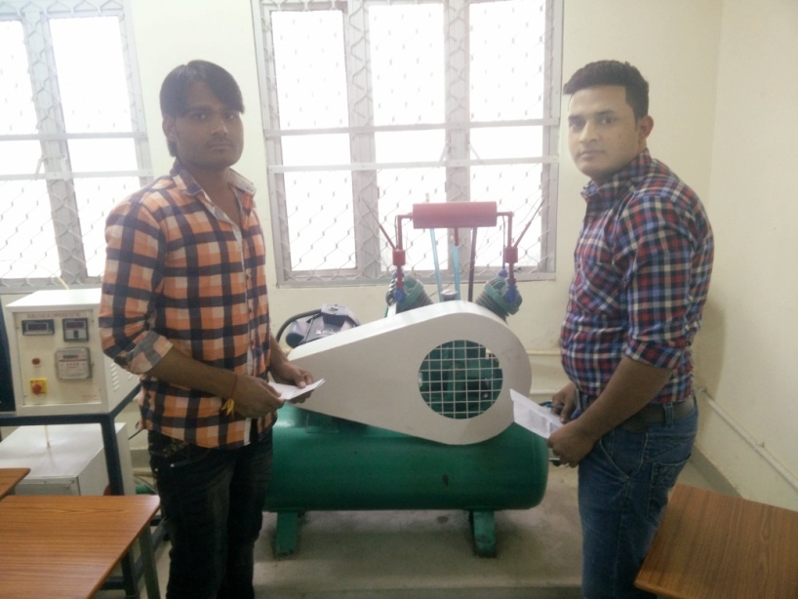

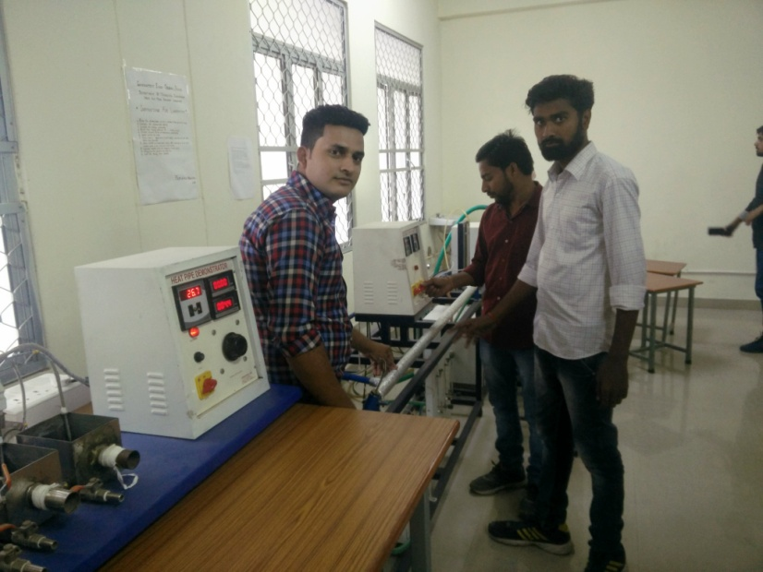

**REFRIGERATION AND AIR CONDITIONING LAB**

Major equipments in Refrigeration and Air Conditioning lab are as following:

* Vapor compression refrigeration test rig
* Ice plant test rig
* Air conditioning test rig
* Double-stage air compressor test rig

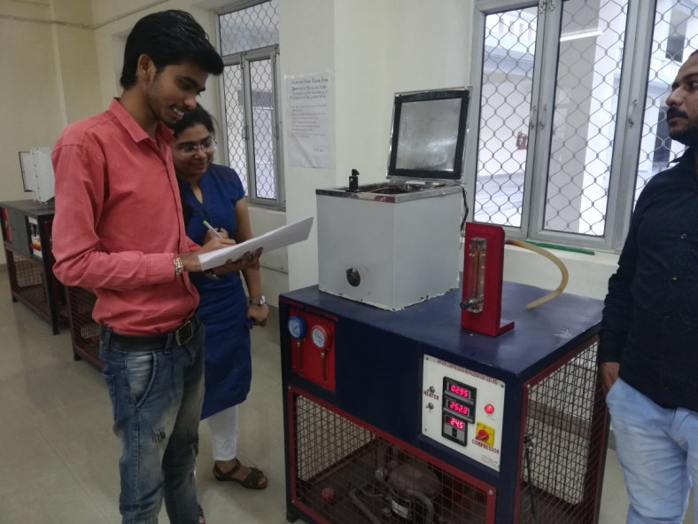

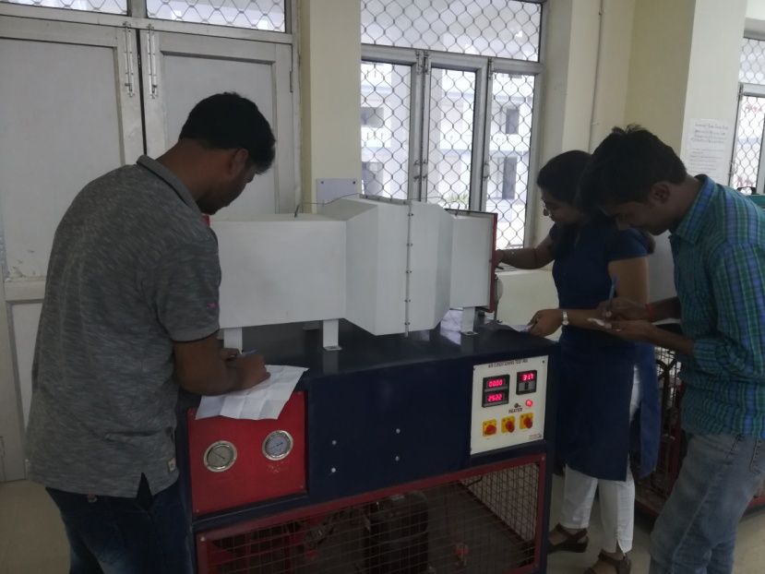

.

**AUTOMOBILE AND IC ENGINE LAB**

Major equipments in Automobile and IC engine lab are as following:

* Four cylinder four stroke petrol engine test rig
* Four cylinder four stroke diesel engine test rig
* Single cylinder four stroke diesel engine test rig
* Steering mechanism
* Differential gear mechanism of rear axle
* Gear box
* Cut section model of fuel supply system of SI engine
* Cut section model of fuel supply system of CI engine
* Suspension system

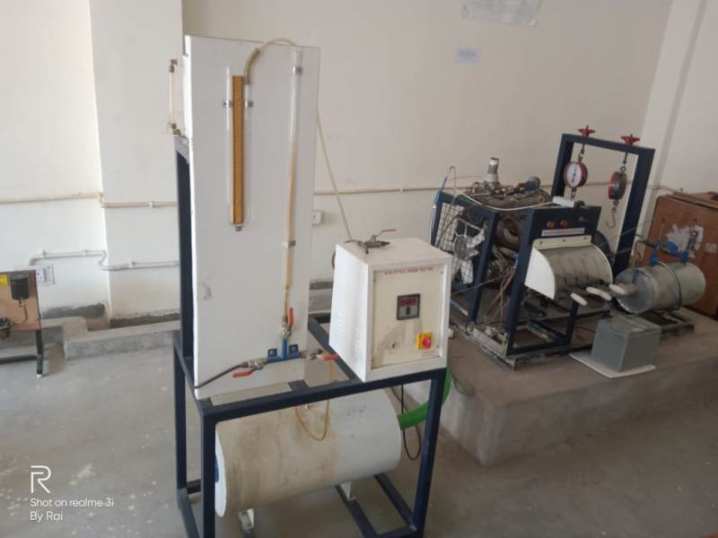

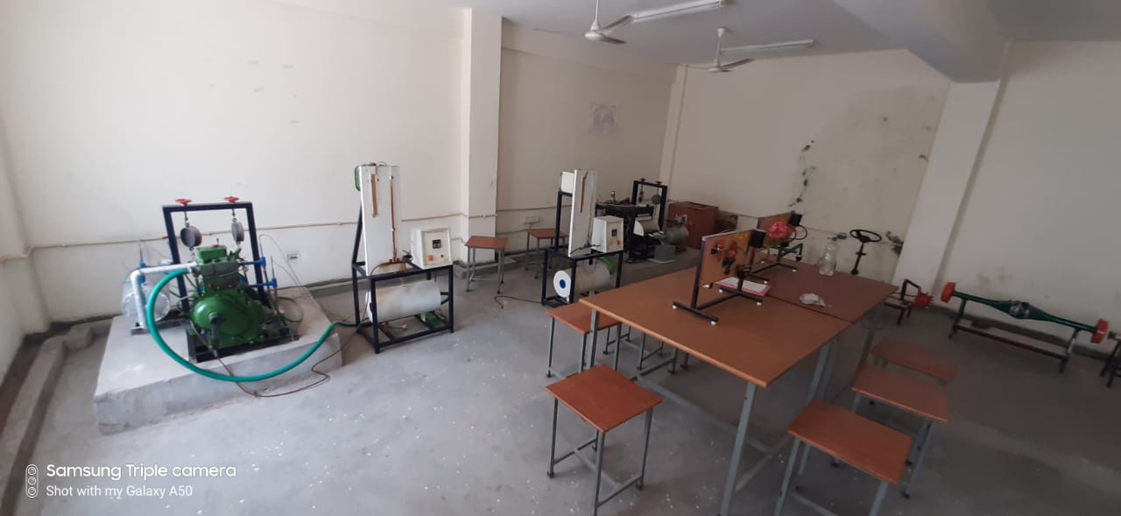

**THERMODYNAMICS LAB**

Major apparatus in Thermodynamics lab are as following:

* Model of Lancashire Boiler
* Model of Babcock and Wilcox Boiler
* Model of two stroke petrol engine
* Model of four stroke petrol engine
* Model of two stroke diesel engine
* Model of four stroke diesel engine
* Model of velocity compounded steam turbine
* Model of pressure compounded steam turbine
* Model of Gas turbine

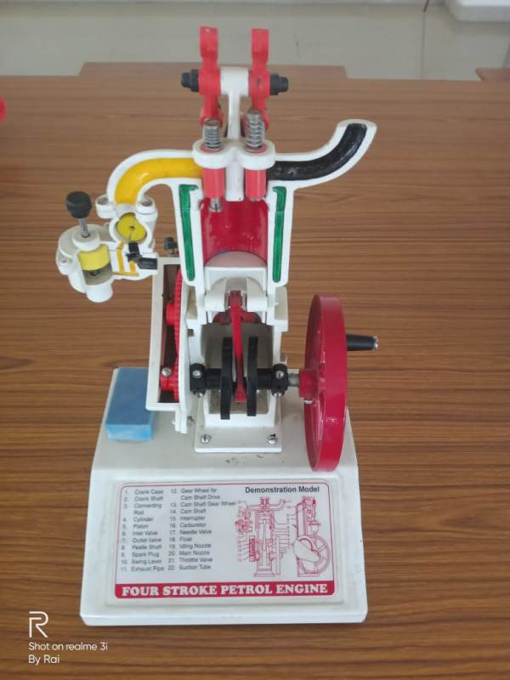

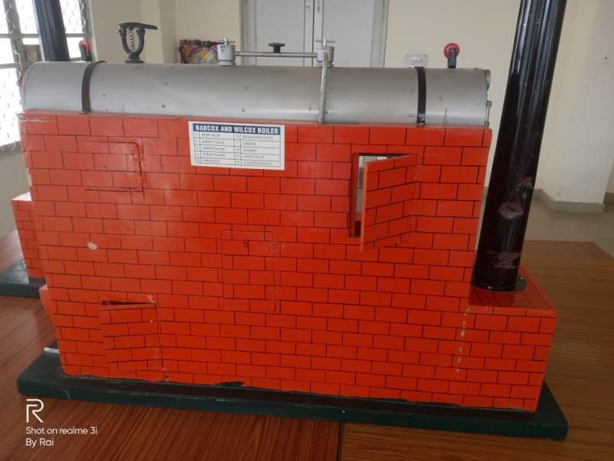

**MATERIAL SCIENCE AND MATERIAL TESTING LAB**

Major equipments in Material Science and material testing lab are as following:

* Universal Testing machine
* Impact Test
* Hardness Tester
* Creep testing Machine
* Fatigue Testing machine
* Injection Moulding
* Polishing machine
* Muffle Furnace
* Specimen Cutting Machine
* Torsion Testing machine
* Spring testing machine

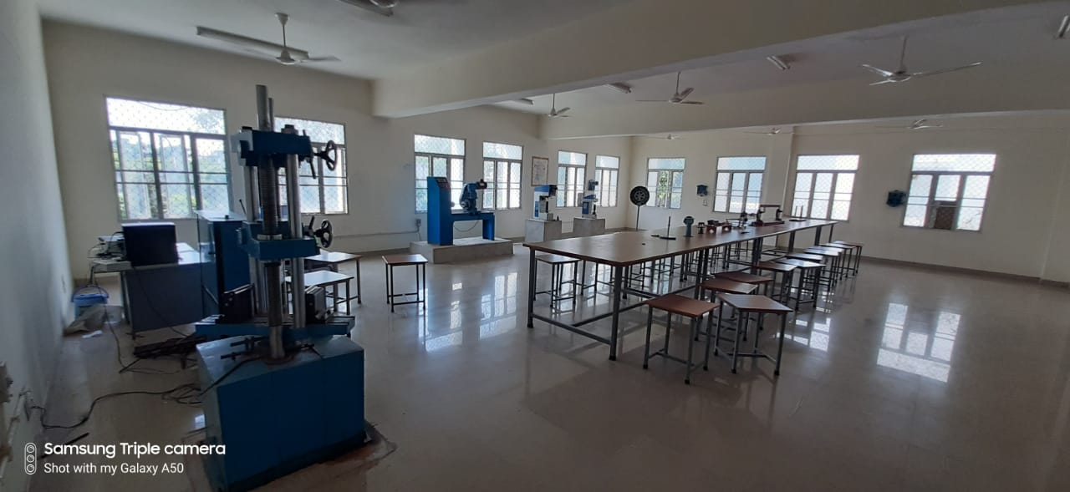

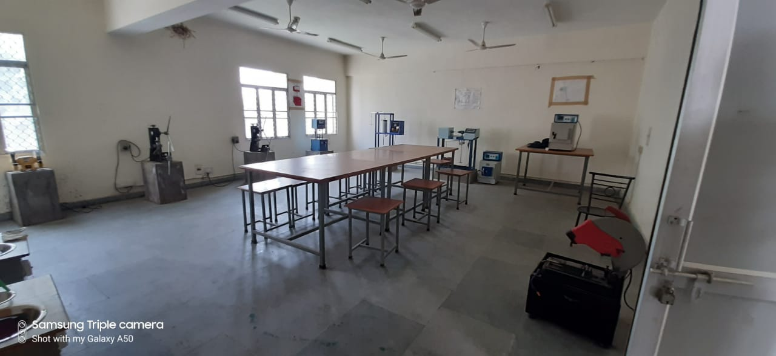

**WORKSHOP**

Major equipments in Workshop are as following:

* Lathe machine with 3 jaw and 4 jaw chuck
* Lathe machine 5 feet 6 inch with 1hp motor
* Shearing machine
* Pedestal grinder with 8 inch wheel( double), 2hp & 3 phase motor
* Pillar electric drill machine, 2hp & 3 phase motor
* Power hacksaw with auto stop hydraulic
* Power hammer
* Abrasive cut off wheel machine
* Power grinder
* Polishing machine
* Vertical milling machine
* Horizontal milling machine
* Milling machine cutter
* Shaper machine
* Surface grinding machine
* Tool and cutter grinding machine
* Moulding machine
* Tube bending machine
* Press machine
* Spring testing machine
* Plastic moulding machine
* Arbor press
* Muffle furnace
* Gas welding machine
* Arc welding machine

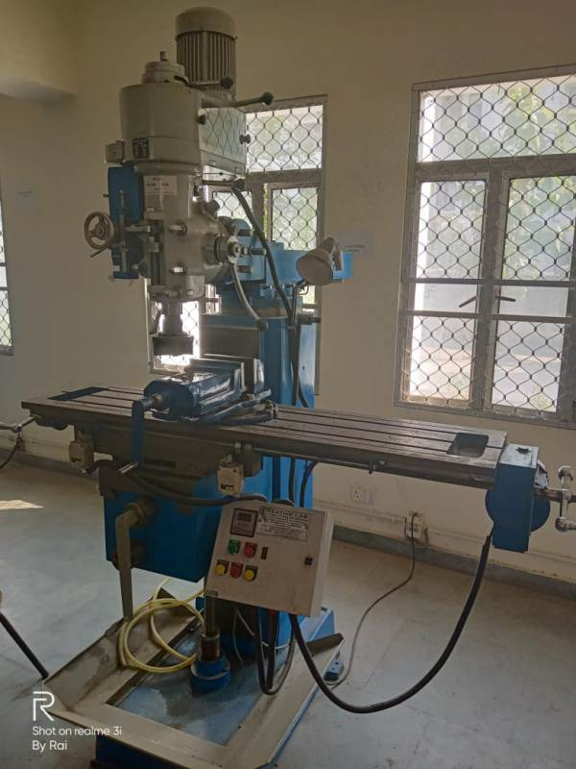

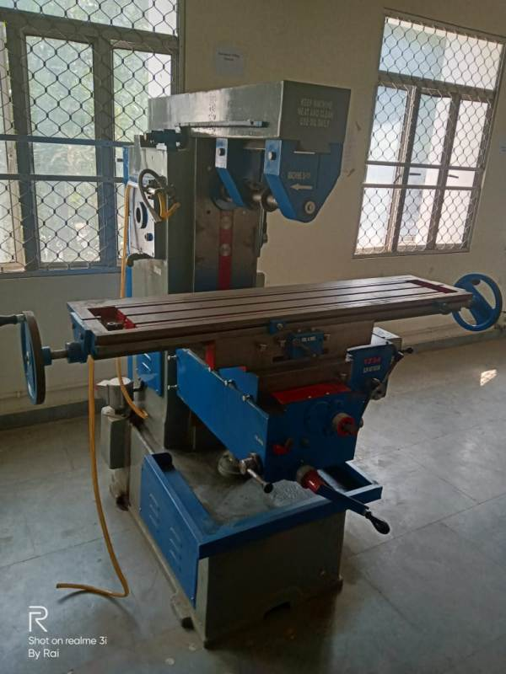

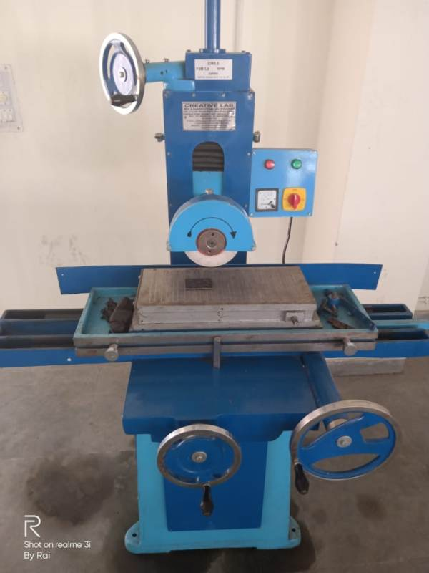

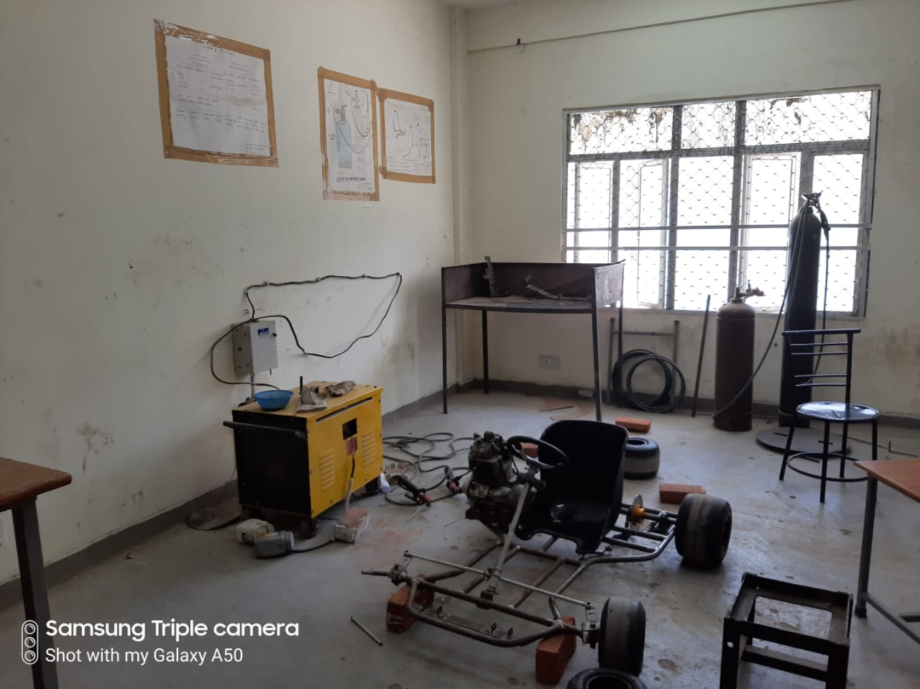

**MACHINE DESIGN LAB**

Major apparatus in Machine design lab are as following:

* Model of cotter Joint.
* Model of knuckle Joint.
* Model of Muff coupling.
* Model of Flexible coupling.
* Model of Helical Spring.
* Model of Screw Jack.

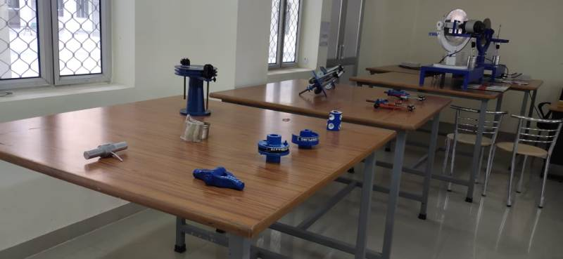

**THEORY OF MACHINES LAB**

Major apparatus in Theory of Machines lab are as following:

* Study of inversion of four bar mechanism
* Study of inversion of single slider crank mechanism
* Study of gyroscopic couple
* Study of simple and compound gear trains

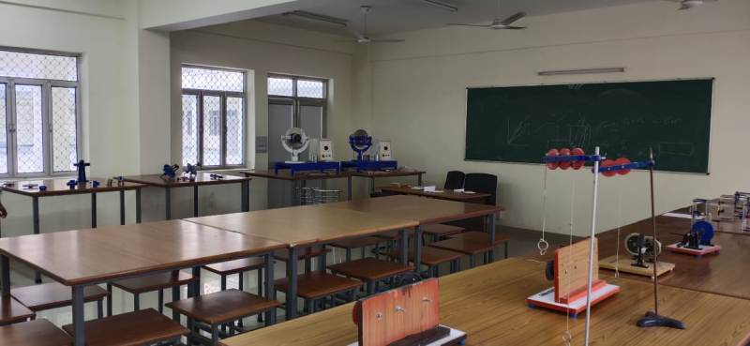

**MEASUREMENT AND METROLOGY LAB**

Major apparatus in Measurement and Metrology are as following:

* Vernier Caliper , Micrometer,
* Slip Gauges, Feeler Gauge, Plug gauge, Limit Gauge
* Dial Indicator
* Plug & Ring Tape gauge
* Sine Bar
* Bevel Protector
* Surface Plate
* Stain gauge Indicator
* Electron Digital Micrometer
* Tachometer, Stroboscope

**CAD AND ENGINEERING DRAWING LAB**

* Number of computers- 30
* Software : ANSYS

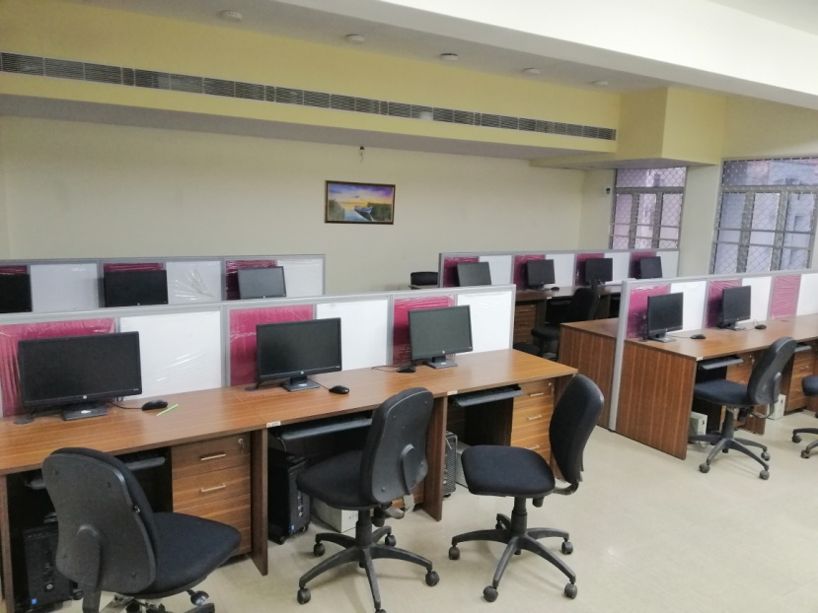

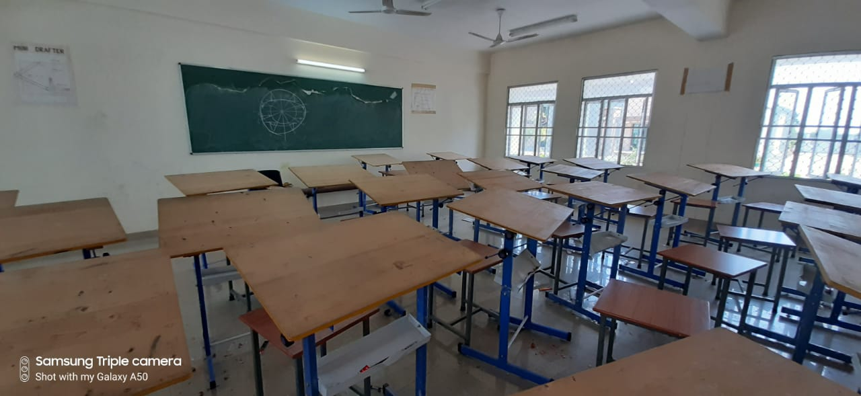

**PROJECT LAB**

This Lab has provided a platform for students projects under the guidance of faculty members. The facility has been utilized by B.Tech students extensively for their project work.

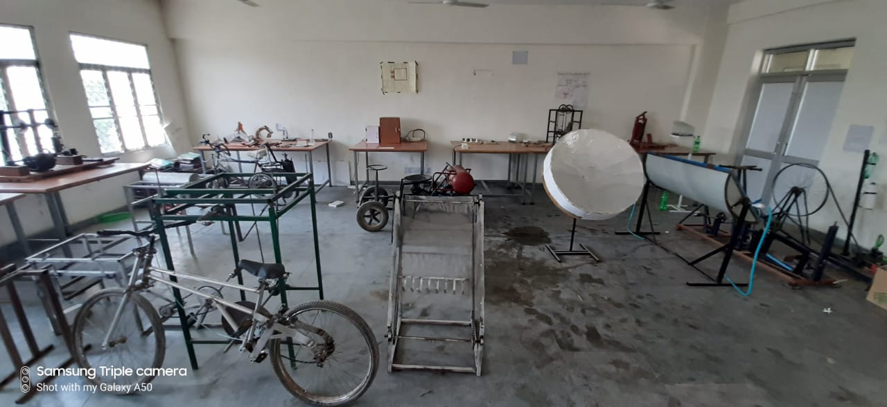

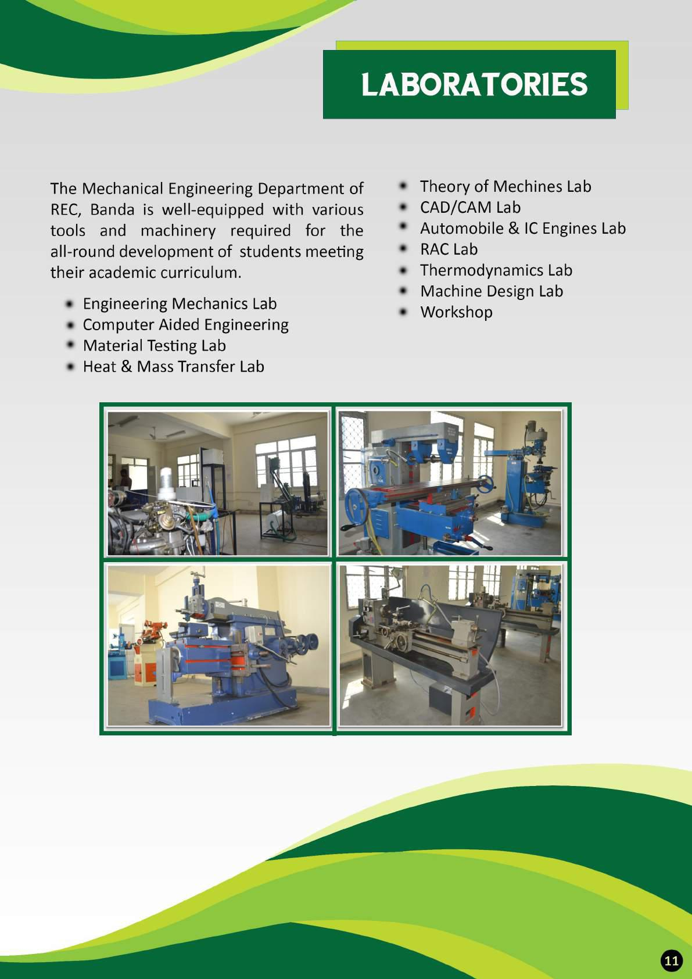

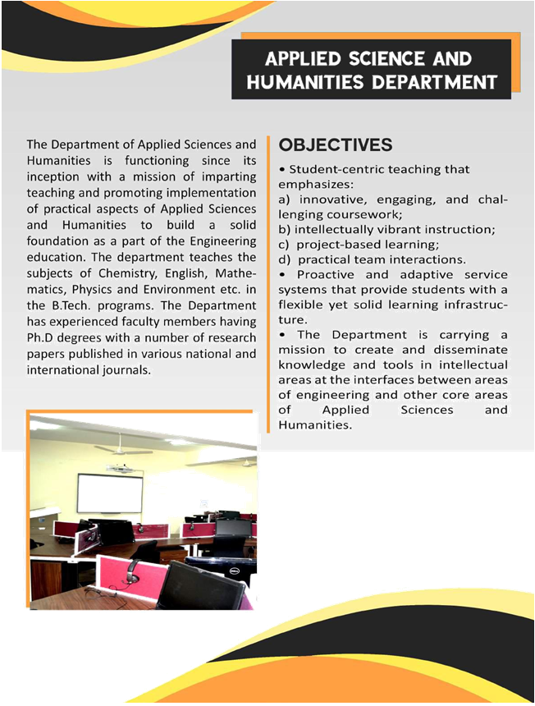

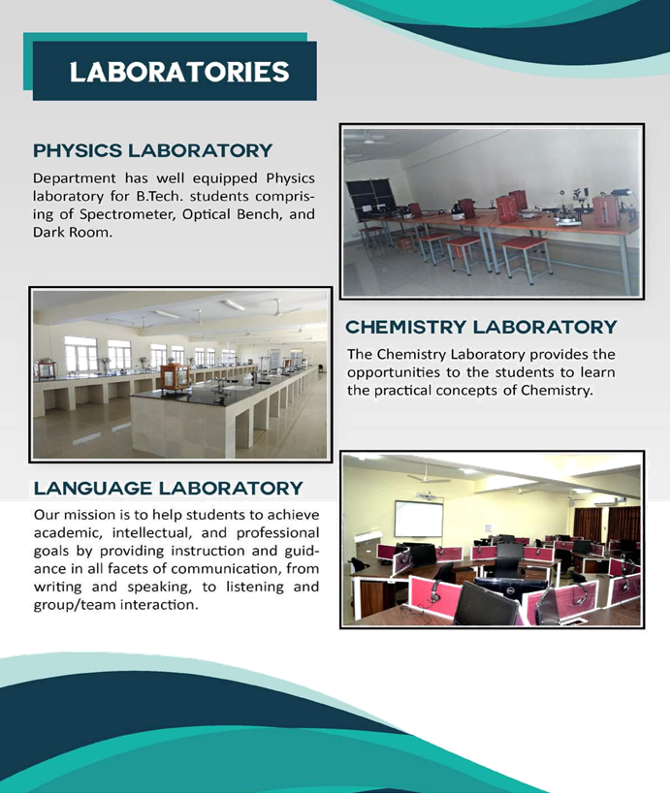

The state-of-the-art language laboratory provides an advanced language teaching/learning experience. The laboratory has 30 computers and a teacher console empowered with iTell Langauge Lab software. The software provideseffective learning methodologies and creates better interaction between teacher and students.

**Programmes Offered**

Rajkiya Engineering College has been providing Bachelor’s Degree Program in three branches namely Information Technology, Mechanical Engineering and Electrical Engineering.



The institute admits students for its bachelor in Technology (B.Tech) programme from all over India through the competitive Common Entrance Test UPSEE. Seats are filled by UPSEE counseling.

|  |  |  |
| --- | --- | --- |
| **S.No.** | **Course Name** | **Duration** |
|  |  |  |
| **1** | **Information Technology** | **4 years** |
| **2** | **Mechanical Engineering** | **4 years** |
| **3** | **Electrical Engineering** | **4 years** |

**Student Strength**

Students Strength: Sanctioned Intake = 180 (60 in each branch)

Actual Intake: Students admitted in first year in 2017-18

|  |  |  |  |
| --- | --- | --- | --- |
| S.No. | IT | ME | EE |
| Actual Intake | 61 | 56 | 60 |

**LIST OF STUDENTS**

1. NAME OF SEMESTER : **(2017-18)**

2. NAME OF COURSE : B.TECH (1st Year)

3. NAME OF BRANCH : **INFORMATION TECHNOLOGY.**

|  |  |  |  |  |
| --- | --- | --- | --- | --- |
| **S.N** | **ROLL NO.** | **NAME OF STUDENT** | **CATEGAOY** | GENDER |
|  | 1773413001 | Abhishek Kumar (D/Y) | SC | Male |
|  | 1773413002 | Ajeet Kumar | SC | Male |
|  | 1773413003 | AkankshaGautam | SC | Female |
|  | 1773413004 | Akash Kumar Singh | SC | Male |
|  | 1773413005 | Akil Ahmad | OBC | Male |
|  | 1773413006 | AlokKanaujia | SC | Male |
|  | 1773413007 | Amit Kumar | SC | Male |
|  | 1773413008 | AniketGhanghoriya | SC | Male |
|  | 1773413009 | AnkitVerma | OBC | Male |
|  | 1773413010 | Anuj Gupta (D/Y) | OBC | Male |
|  | 1773413011 | AshishRai | GEN | Male |
|  | 1773413012 | Ashwani Kumar | SC | Male |
|  | 1773413013 | Ayush Singh | SC | Male |
|  | 1773413014 | Devesh Kr. Verma | SC | Male |
|  | 1773413015 | Gopal Singh Chauhan | OBC | Male |
|  | 1773413016 | Hemant Gaur (F/W) | GEN | Male |
|  | 1773413017 | Krishna Avtar | SC | Male |
|  | 1773413018 | LalitKatherya | SC | Male |
|  | 1773413019 | Leepakshi Singh Banswal | SC | Female |
|  | 1773413020 | MandeepChargotra (J&K) | OBC | Male |
|  | 1773413021 | MukulDev | ST | Male |
|  | 1773413022 | Munendra Singh | SC | Male |
|  | 1773413023 | Navneet Kumar | SC | Male |
|  | 1773413024 | Nitin Kumar Pal | OBC | Male |
|  | 1773413025 | Pankaj Kumar | SC | Male |
|  | 1773413026 | PrashantYadav | OBC | Male |
|  | 1773413027 | Priya Sharma | OBC | Female |
|  | 1773413028 | Rahul Kumar | SC | Male |
|  | 1773413029 | Rahul Singh | SC | Male |
|  | 1773413030 | Rajesh Kumar | SC | Male |
|  | 1773413031 | RiyaSahu | OBC | Female |
|  | 1773413032 | Rohit Kumar | ST | Male |
|  | 1773413033 | RohitYadav | OBC | Male |
|  | 1773413034 | SachinKushwaha | OBC | Male |
|  | 1773413035 | Sanjay Kumar | SC | Male |
|  | 1773413036 | SejalAgrawal | GEN | Female |
|  | 1773413037 | Shaloo Singh | OBC | Female |
|  | 1773413038 | Shivam | SC | Male |
|  | 1773413039 | Shivam Gupta | OBC | Male |
|  | 1773413040 | Shivam Kr. Sagar | SC | Male |
|  | 1773413041 | Shivangi Gupta | OBC | Female |
|  | 1773413042 | ShivaniKumari | SC | Female |
|  | 1773413043 | ShrutiTripathi | GEN | Female |
|  | 1773413044 | Shubham Kumar S/O BrijmohanGond | ST | Male |
|  | 1773413045 | Shubham Kumar | SC | Male |
|  | 1773413046 | SomendraShekhar (F/W) | GEN | Male |
|  | 1773413047 | Son Prakash | SC | Male |
|  | 1773413048 | SonuPaswan | SC | Male |
|  | 1773413049 | Sujeet Kumar | SC | Male |
|  | 1773413050 | Suleman | OBC | Male |
|  | 1773413051 | Suraj Kumar | SC | Male |
|  | 1773413052 | SuyashKhare (F/W) | GEN | Male |
|  | 1773413053 | UjjawalKannojiya | SC | Male |
|  | 1773413054 | Utsav Singh | GEN | Male |
|  | 1773413055 | Vijay Singh | SC | Male |
|  | 1773413056 | Vinay Kumar Arya | SC | Male |
|  | 1773413057 | Vishal Kumar Gond | ST | Male |
|  | 1773413058 | VishuDangi | OBC | Male |
|  | 1773413059 | Yash Gupta | GEN | Male |
|  | 1773413060 | YashiAgarwal | GEN | Female |
|  | 1773413061 | Yawan Kumar | SC | Male |

**LIST OF STUDENTS**

1. NAME OF SEMESTER : **(2017-18)**

2. NAME OF COURSE : B.TECH (1st Year)

3. NAME OF BRANCH : **ELECTRICAL ENGINEERING.**

|  |  |  |  |  |
| --- | --- | --- | --- | --- |
| **S.N** | **ROLL NO.** | **NAME OF STUDENT** | **CATEGAOY** | **Gender** |
| **1.** | 1773420001 | Abhijeet Kumar | OBC | Male |
| **2.** | 1773420002 | Abhishek Gupta | OBC | Male |
| **3.** | 1773420003 | Adarash Kumar Chaudhari | SC | Male |
| **4.** | 1773420004 | AjeetSagar | SC | Male |
| **5.** | 1773420005 | Akanksha Patel | OBC | Female |
| **6.** | 1773420006 | AkashSaxena | GEN | Male |
| **7.** | 1773420007 | AkhilRatan Singh | SC | Male |
| **8.** | 1773420008 | Akshay Kumar | SC | Male |
| **9.** | 1773420009 | Amrit Kumar | SC | Male |
| **10.** | 1773420010 | Anjali Sonkar | SC | Female |
| **11.** | 1773420011 | Ankit Kumar | SC | Male |
| **12.** | 1773420012 | Ankur Kumar Gautam | SC | Male |
| **13.** | 1773420013 | AnkushYadav | OBC | Male |
| **14.** | 1773420014 | AnubhavYadav | OBC | Male |
| **15.** | 1773420015 | ArunGautam | SC | Male |
| **16.** | 1773420016 | Arvind Kumar | SC | Male |
| **17.** | 1773420017 | AshishChaudhary | SC | Male |
| **18.** | 1773420018 | Atul Kumar Gaud | ST | Male |
| **19.** | 1773420019 | Awadhesh Kumar Verma | OBC | Male |
| **20.** | 1773420020 | BipinChaudhary | SC | Male |
| **21.** | 1773420021 | BudhaPriya Rahul | SC | Male |
| **22.** | 1773420022 | Chandan Kumar | SC | Male |
| **23.** | 1773420023 | Deepak Kumar (Withdraw) | SC | Male |
| **24.** | 1773420024 | Deepak Ratnakar | SC | Male |
| **25.** | 1773420025 | DheerajBabu | SC | Male |
| **26.** | 1773420026 | Dheeraj Kumar Singh | SC | Male |
| **27.** | 1773420027 | Duli Chandra | SC | Male |
| **28.** | 1773420028 | Durgesh Kumar | SC | Male |
| **29.** | 1773420029 | ItikaSagar | SC | Female |
| **30.** | 1773420030 | Mananjaya Kumar | SC | Male |
| **31.** | 1773420031 | Manjeet Singh | SC | Male |
| **32.** | 1773420032 | ManmohanLal Singh | SC | Male |
| **33.** | 1773420033 | MohdShahrukh | OBC | Male |
| **34.** | 1773420034 | MonuKapadia | SC | Male |
| **35.** | 1773420035 | Nand Kishore Bharti | SC | Male |
| **36.** | 1773420036 | Neelesh Mishra (F/W) | GEN | Male |
| **37.** | 1773420037 | NitishDwivedi (F/W) | GEN | Male |
| **38.** | 1773420038 | Pawan Kumar | SC | Male |
| **39.** | 1773420039 | PinkiKumari | SC | Female |
| **40.** | 1773420040 | Prashant Patel | OBC | Male |
| **41.** | 1773420041 | Ram Singh (F/W) | OBC | Male |
| **42.** | 1773420042 | Ravi Prakash Bind | OBC | Male |
| **43.** | 1773420043 | Rohit Kumar Yadav | OBC | Male |
| **44.** | 1773420044 | SandhyaKannaujiya | SC | Female |
| **45.** | 1773420045 | Satendra Kumar Saroj | SC | Male |
| **46.** | 1773420046 | Satyaveer Singh | OBC | Male |
| **47.** | 1773420047 | Saurabh Gupta | OBC | Male |
| **48.** | 1773420048 | Saurabh Kumar | OBC | Male |
| **49.** | 1773420049 | SaurabhSukla | GEN | Male |
| **50.** | 1773420050 | Saurabh Singh | OBC | Male |
| **51.** | 1773420051 | Shashi | SC | Female |
| **52.** | 1773420052 | Shiv Pratap Singh | SC | Male |
| **53.** | 1773420053 | ShubhamSaroj | ST | Male |
| **54.** | 1773420054 | SumitKharwar | SC | Male |
| **55.** | 1773420055 | Sunny Saroj | ST | Male |
| **56.** | 1773420056 | TanjilaShakir | SC | Female |
| **57.** | 1773420057 | Uttam Singh Yadav | OBC | Male |
| **58.** | 1773420058 | Vishal Gautam | SC | Male |
| **59.** | 1773420059 | Vishvajeet Kumar Singh | OBC | Male |
| **60.** | 1773420060 | ZaminAbass( J&K) | GEN | Male |

**LIST OF STUDENTS**

1. NAME OF SEMESTER : **(2017-18)**

2. NAME OF COURSE : B.TECH (1st Year)

3. NAME OF BRANCH : **MECHANICAL ENGINEERING.**

|  |  |  |  |  |
| --- | --- | --- | --- | --- |
| **S.N** | **ROLL NO.** | **NAME OF STUDENT** | **CATEGAOY** | **GENDER** |
|  | 1773440001 | Abhinandan Kumar Yadav (F/W) | OBC | Male |
|  | 1773440002 | Abhishek Kumar | SC | Male |
|  | 1773440003 | Akash Kumar | OBC | Male |
|  | 1773440004 | Akhilesh Kumar Tejasvi | SC | Male |
|  | 1773440005 | Ankit Kumar | SC | Male |
|  | 1773440006 | Ankur Kumar | SC | Male |
|  | 1773440007 | AnujUpadhyay | GEN | Male |
|  | 1773440008 | Ashish Kumar Chaurasiya | OBC | Male |
|  | 1773440009 | Ashish Kumar Gautam | SC | Male |
|  | 1773440010 | AshutoshVishwakarma (F/W) | OBC | Male |
|  | 1773440011 | Chandrapal | **SC** | Male |
|  | 1773440012 | Deepak Kumar | **SC** | Male |
|  | 1773440013 | Deepak Mishra | GEN | Male |
|  | 1773440014 | GyanSourabh | SC | Male |
|  | 1773440015 | Himanshu | **SC** | Male |
|  | 1773440016 | Irfan Bashir ( J&K) | MIN-GEN | Male |
|  | 1773440017 | Jayant Kumar | **SC** | Male |
|  | 1773440018 | KajalMalhotra | **SC** | Female |
|  | 1773440019 | Km Manisha Pal | OBC | Female |
|  | 1773440020 | KshamaRajpoot | OBC | Female |
|  | 1773440021 | Kuldeep Kumar | OBC | Male |
|  | 1773440022 | Mithilesh Kumar | **SC** | Male |
|  | 1773440023 | Mukesh Kumar | **SC** | Male |
|  | 1773440024 | Nitish Kumar | **SC** | Male |
|  | 1773440025 | Nityansh Singh | GEN | Male |
|  | 1773440026 | Omkar | OBC | Male |
|  | 1773440027 | Piyush Kumar Anand | SC | Male |
|  | 1773440028 | PrashantTiwari | GEN | Male |
|  | 1773440029 | Prince Kumar Kushwaha (F/W) | OBC | Male |
|  | 1773440030 | Punit Kumar | ST | Male |
|  | 1773440031 | Rabin Kumar | ST | Male |
|  | 1773440032 | Ram PragatYadav | OBC | Male |
|  | 1773440033 | RidhiPandey | GEN | Female |
|  | 1773440034 | Rohit Kumar Gautam | SC | Male |
|  | 1773440035 | SachinPratap Singh | SC | Male |
|  | 1773440036 | SachinShakya | OBC | Male |
|  | 1773440037 | Sadashiv Mishra (F/W) | GEN | Male |
|  | 1773440038 | Sandeep Kumar | SC | Male |
|  | 1773440039 | SantoshGiri | OBC | Male |
|  | 1773440040 | SarveshJayasaval | OBC | Male |
|  | 1773440041 | SaurabhSonkar | **SC** | Male |
|  | 1773440042 | Saurav Kumar | **SC** | Male |
|  | 1773440043 | Shailesh Kumar | OBC | Male |
|  | 1773440044 | Shivam Kumar | **SC** | Male |
|  | 1773440045 | Shivam Singh | **SC** | Male |
|  | 1773440046 | ShivamVerma | OBC | Male |
|  | 1773440047 | Singh PrashantArvind Ku. | ST | Male |
|  | 1773440048 | SubhashArya | **SC** | Male |
|  | 1773440049 | SudhirGautam | **SC** | Male |
|  | 1773440050 | Sumit Kumar | **SC** | Male |
|  | 1773440051 | Suraj Kumar Gupta | OBC | Male |
|  | 1773440052 | Vikash Kumar | **SC** | Male |
|  | 1773440053 | Vikash Kumar Sonkar | **SC** | Male |
|  | 1773440054 | Vinod Kumar | **SC** | Male |
|  | 1773440055 | Vishnu Kumar | SC | Male |
|  | 1773440057 | VivekGhanghoriya | SC | Male |

**List of Students admitted in second year via Lateral Entry**

**LIST OF STUDENTS**

1. NAME OF SEMESTER : **(2017-18)**

2. NAME OF COURSE : B.TECH (2nd Year)

3. NAME OF BRANCH : **INFORMATION TECH**.

|  |  |  |  |  |
| --- | --- | --- | --- | --- |
| **S.NO.** | **ROLL NO.** | **NAME OF STUDENT** | **CATEGAOY** | **GENDER** |
|  | 1773413801 | DeveshAhirwar | SC | Male |
|  | 1773413802 | Manjeet Singh | SC | Male |
|  | 1773413901 | Ajeet Kumar | SC | Male |
|  | 1773413902 | AkankshaDubey | GEN | Female |
|  | 1773413903 | Akanksha Singh | GEN | Female |
|  | 1773413904 | Atul Kumar | OBC | Male |
|  | 1773413905 | Deepa | SC | Female |
|  | 1773413906 | Navneet Prasad | SC | Male |
|  | 1773413907 | Pankaj Kumar Mishra | GEN | Male |
|  | 1773413908 | Ravi Yadav | OBC | Male |
|  | 1773413909 | Rishabh Kumar | OBC | Male |
|  | 1773413910 | Shiva Singh | GEN | Male |

**LIST OF STUDENTS**

1. NAME OF SEMESTER : **(2017-18)**

2. NAME OF COURSE : B.TECH (2nd Year)

3. NAME OF BRANCH : **ELECTRICAL ENGINEERING.**

|  |  |  |  |  |
| --- | --- | --- | --- | --- |
| **S.N** | **ROLL NO.** | **NAME OF STUDENT** | **CATEGAOY** | **GENDER** |
| **1** | 1773420901 | AbhishekVerma | SC | Male |
| **2** | 1773420902 | Akhilesh Pal | SC | Male |
| **3** | 1773420903 | AshishVishwakarma | OBC | Male |
| **4** | 1773420904 | Devendra Kumar | SC | Male |
| **5** | 1773420905 | GauravKuma | SC | Male |
| **6** | 1773420906 | NamartaKumari | SC | Female |
| **7** | 1773420907 | Ravi Kumar | ST | Male |
| **8** | 1773420908 | Ruby Rani | SC | Female |
| **9** | 1773420909 | ShambhuSharan Sharma | OBC | Male |
| **10** | 1773420910 | VikasPandey | GEN | Male |
| **11** | 1773420911 | Vikram Kumar | SC | Male |

**LIST OF STUDENTS**

1. NAME OF SEMESTER :  **(2017-18)**

2. NAME OF COURSE : B.TECH (2nd Year)

3. NAME OF BRANCH : **MECHANICAL ENGINEERING.**

|  |  |  |  |  |
| --- | --- | --- | --- | --- |
| **S.NO.** | **ROLL NO.** | **NAME OF STUDENT** | **CATEGAOY** | **GENDER** |
|  | 1773440901 | AdeshGautam | SC | Male |
|  | 1773440902 | Aditya Kumar | SC | Male |
|  | 1773440903 | Dinesh Kumar Pal | OBC | Male |
|  | 1773440904 | Gautam Kumar | SC | Male |
|  | 1773440905 | HimanshuPandey | GEN | Male |
|  | 1773440906 | Isahan Ali | OBC | Male |
|  | 1773440907 | Karmendr Kumar | SC | Male |
|  | 1773440908 | MusaibManzoorNaik | GEN | Male |
|  | 1773440909 | NeelamSuman | SC | Female |
|  | 1773440910 | Om PrakashSah | ST | Male |
|  | 1773440911 | PrityKushwaha | OBC | Female |
|  | 1773440912 | Rajat Kumar Kaushal | SC | Male |
|  | 1773440913 | Viswas Kumar Tyagee | SC | Male |

**Exam Result Analysis(2017-18)**

|  |  |  |  |  |  |  |  |  |  |  |  |  |  |  |  |  |  |  |  |
| --- | --- | --- | --- | --- | --- | --- | --- | --- | --- | --- | --- | --- | --- | --- | --- | --- | --- | --- | --- |
|  |  | |  | | | |  | |  | |  |  | |  |  | |  | |  |
|  | | | | | | | | | | | | | | | | | | |
|  |  | |  |  | |  | |  | |  | | | |  |  | |  | |  |
| **S.no** | **Branch** | | **Year** | **Total Students** | | **No of Passed Students** | | **% of Passed Students** | | **No of Students (%)** | | | | | | | | |
| $≥$**75** | | **74-70** | **69-60** | | | **59-50** | | **<50** |
| 1 | **IT** | | I | 63 | | 59 | | 93.7 | | 14 | | 7 | 34 | | | 7 | | 1 |
| 2 |  | | II | 62 | | 62 | | 100 | | 18 | | 24 | 18 | | | 2 | | 0 |
| 3 |  | | III | 54 | | 54 | | 100 | | 6 | | 15 | 29 | | | 4 | | 0 |
| 4 |  | | IV | 50 | | 50 | | 100 | | 11 | | 15 | 24 | | | 0 | | 0 |
|  |  | |  |  | |  | |  | |  | |  |  | | |  | |  |
| 5 | **EE** | | I | 59 | | 58 | | 98.3 | | 8 | | 19 | 26 | | | 6 | | 0 |
| 6 |  | | II | 63 | | 63 | | 100 | | 13 | | 23 | 24 | | | 3 | | 0 |
| 7 |  | | III | 55 | | 55 | | 100 | | 17 | | 15 | 22 | | | 1 | | 0 |
| 8 |  | | IV | 56 | | 56 | | 100 | | 12 | | 30 | 14 | | | 0 | | 0 |
|  |  | |  |  | |  | |  | |  | |  |  | | |  | |  |
| 9 | **ME** | | I | 57 | | 56 | | 98.2 | | 14 | | 13 | 23 | | | 7 | | 0 |
| 10 |  | | II | 69 | | 69 | | 100 | | 10 | | 19 | 38 | | | 2 | | 0 |
| 11 |  | | III | 56 | | 55 | | 98.2 | | 7 | | 6 | 31 | | | 11 | | 1 |
| 12 |  | | IV | 68 | | 68 | | 100 | | 8 | | 31 | 29 | | | 0 | | 0 |
|  |  | | **Total** | **712** | | **705** | | **99.0** | |  | |  |  | | |  | |  |
|  |  | |  |  | |  | |  | |  | |  |  | | |  | |  |
|  |  | |  |  | |  | |  | |  | |  |  | | |  | |  |
| **Detail of Failed Students:** | | | |  | |  | |  | |  | |  |  | | |  | |  |
| **Branch** | | **Roll No** | | **Year** | **Percentage** | | |
| IT | | 1673413002 | | I | 35 | | |
|  | | 1773413004 | | I | 56 | | |
|  | | 1773413033 | | I | 53 | | |
|  | | 1773413035 | | I | 54 | | |
|  | |  | |  |  | | |
| EE | | 1773420025 | | I | 50 | | |
|  | |  | |  |  | | |
| ME | | 1773440053 | | I | 56 | | |
|  | | 1673440903 | | III | 39 | | |

**Transition Rate of First Year Students**

B.Tech Electrical Engineering

|  |  |  |  |
| --- | --- | --- | --- |
|  | No. of Student in 1st Sem | No. of Student 2nd Sem. | No. of Student passed from 1st Sem to 2nd Sem in the first Attempt |
| Total | 59 | 59 | 59 |
| SC/ST | 36 | 36 | 36 |
| Girl | 7 | 7 | 7 |

B.Tech Electrical Engineering

|  |  |  |  |
| --- | --- | --- | --- |
|  | No. of Student in 2nd Sem | No. of Student passed from 1st Sem to 2nd Sem in the first Attempt | No. of Student passed both Sem in the first Attempt  (i.e.1st Sem to 2nd Sem) |
| Total | 59 | 59 | 58 |
| SC/ST | 36 | 36 | 35 |
| Girl | 7 | 7 | 7 |

B.Tech Mechanical Engineering

|  |  |  |  |
| --- | --- | --- | --- |
|  | No. of Student in 1st Sem | No. of Student 2nd Sem. | No. of Student passed from 1st Sem to 2nd Sem in the first Attempt |
| Total | 57* | 57* | 57 |
| SC/ST | 34 | 34 | 34 |
| Girl | 4 | 4 | 4 |

B.Tech Mechanical Engineering

|  |  |  |  |
| --- | --- | --- | --- |
|  | No. of Student in 2nd Sem | No. of Student passed from 1st Sem to 2nd Sem in the first Attempt | No. of Student passed both Sem in the first Attempt  (i.e.1st Sem to 2nd Sem) |
| Total | 57* | 57 | 56 |
| SC/ST | 34 | 34 | 33 |
| Girl | 4 | 4 | 4 |

B.Tech Information Technology

|  |  |  |  |
| --- | --- | --- | --- |
|  | No. of Student in 1st Sem | No. of Student 2nd Sem. | No. of Student passed from 1st Sem to 2nd Sem in the first Attempt |
| Total | 63* | 63* | 63 |
| SC/ST | 38 | 38 | 38 |
| Girl | 11 | 11 | 11 |

B.Tech Information Technology

|  |  |  |  |
| --- | --- | --- | --- |
|  | No. of Student in 2nd Sem | No. of Student passed from 1st Sem to 2nd Sem in the first Attempt | No. of Student passed both Sem in the first Attempt  (i.e.1st Sem to 2nd Sem) |
| Total | 63* | 63 | 59 |
| SC/ST | 38 | 38 | 35 |
| Girl | 11 | 11 | 11 |

*Ex and Re-admitted Students are included

**GATE QUALIFIED DATA**

Students Qualified GATE(2017-18)

|  |  |  |  |
| --- | --- | --- | --- |
| S. NO. | Branch | Strength | Number of students qualified |
| 1 | Electrical Engineering | 36 | 11 |
| 2 | Mechanical Engineering | 52 | 14 |
| 3 | Information Technology | 40 | 08 |

**Students’ Training Program/ Internship**

* Total 163 students have done internship at various reputed institutes during 2017-18.

|  |  |  |  |  |  |
| --- | --- | --- | --- | --- | --- |
| S.No | Roll No | Organization Name | From Date | To Date | Department/ Discipline |
| 1 | 1573413001 | NIE MYSURU | 11-Jun-18 | 6-Jul-18 | IT |
| 2 | 1573413003 | NIE MYSURU | 11-Jun-18 | 6-Jul-18 | IT |
| 3 | 1573413009 | NIE MYSURU | 11-Jun-18 | 6-Jul-18 | IT |
| 4 | 1573413011 | NIE MYSURU | 11-Jun-18 | 6-Jul-18 | IT |
| 5 | 1573413012 | NIE MYSURU | 11-Jun-18 | 6-Jul-18 | IT |
| 6 | 1573413015 | NIE MYSURU | 11-Jun-18 | 6-Jul-18 | IT |
| 7 | 1573413027 | NIE MYSURU | 11-Jun-18 | 6-Jul-18 | IT |
| 8 | 1573413033 | NIE MYSURU | 11-Jun-18 | 6-Jul-18 | IT |
| 9 | 1573413035 | NIE MYSURU | 11-Jun-18 | 6-Jul-18 | IT |
| 10 | 1673413901 | NIE MYSURU | 11-Jun-18 | 6-Jul-18 | IT |
| 11 | 1673413904 | NIE MYSURU | 11-Jun-18 | 6-Jul-18 | IT |
| 12 | 1673413905 | NIE MYSURU | 11-Jun-18 | 6-Jul-18 | IT |
| 13 | 1673413907 | NIE MYSURU | 11-Jun-18 | 6-Jul-18 | IT |
| 14 | 1673413908 | NIE MYSURU | 11-Jun-18 | 6-Jul-18 | IT |
| 15 | 1673413909 | NIE MYSURU | 11-Jun-18 | 6-Jul-18 | IT |
| 16 | 15734020030 | NIE MYSURU | 19-Jun-18 | 20-Jul-18 | EE |
| 17 | 1573420004 | NIE MYSURU | 19-Jun-18 | 20-Jul-18 | EE |
| 18 | 1573420007 | NIE MYSURU | 19-Jun-18 | 20-Jul-18 | EE |
| 19 | 1573420009 | NIE MYSURU | 19-Jun-18 | 20-Jul-18 | EE |
| 20 | 1573420012 | NIE MYSURU | 19-Jun-18 | 20-Jul-18 | EE |
| 21 | 1573420014 | NIE MYSURU | 19-Jun-18 | 20-Jul-18 | EE |
| 22 | 1573420022 | NIE MYSURU | 19-Jun-18 | 20-Jul-18 | EE |
| 23 | 1573420032 | NIE MYSURU | 19-Jun-18 | 20-Jul-18 | EE |
| 24 | 1573420033 | NIE MYSURU | 19-Jun-18 | 20-Jul-18 | EE |
| 25 | 1573420047 | NIE MYSURU | 19-Jun-18 | 20-Jul-18 | EE |
| 26 | 1573420050 | NIE MYSURU | 19-Jun-18 | 20-Jul-18 | EE |
| 27 | 1673420905 | NIE MYSURU | 19-Jun-18 | 21-Jul-18 | EE |
| 28 | 1573440007 | NIE MYSURU | 19-Jun-18 | 20-Jul-18 | ME |
| 29 | 1573440009 | NIE MYSURU | 19-Jun-18 | 20-Jul-18 | ME |
| 30 | 1573440012 | NIE MYSURU | 19-Jun-18 | 20-Jul-18 | ME |
| 31 | 1573440016 | NIE MYSURU | 19-Jun-18 | 20-Jul-18 | ME |
| 32 | 1573440020 | NIE MYSURU | 19-Jun-18 | 20-Jul-18 | ME |
| 33 | 1573440025 | NIE MYSURU | 19-Jun-18 | 20-Jul-18 | ME |
| 34 | 1573440027 | NIE MYSURU | 19-Jun-18 | 20-Jul-18 | ME |
| 35 | 1573440028 | NIE MYSURU | 19-Jun-18 | 20-Jul-18 | ME |
| 36 | 1573440030 | NIE MYSURU | 19-Jun-18 | 20-Jul-18 | ME |
| 37 | 1573440033 | NIE MYSURU | 19-Jun-18 | 20-Jul-18 | ME |
| 38 | 1573440037 | NIE MYSURU | 19-Jun-18 | 20-Jul-18 | ME |
| 39 | 1573440039 | NIE MYSURU | 19-Jun-18 | 20-Jul-18 | ME |
| 40 | 1573440047 | NIE MYSURU | 19-Jun-18 | 20-Jul-18 | ME |
| 41 | 1573440048 | NIE MYSURU | 19-Jun-18 | 20-Jul-18 | ME |
| 42 | 1573440051 | NIE MYSURU | 19-Jun-18 | 20-Jul-18 | ME |
| 43 | 1573440052 | NIE MYSURU | 19-Jun-18 | 20-Jul-18 | ME |
| 44 | 1573440019 | NIE MYSURU | 19-Jun-18 | 20-Jul-18 | ME |
| 45 | 1573413002 | MNNIT ALLAHABHAD | 11-Jun-18 | 7-Jul-18 | IT |
| 46 | 1573413004 | MNNIT ALLAHABHAD | 11-Jun-18 | 7-Jul-18 | IT |
| 47 | 1573413006 | MNNIT ALLAHABHAD | 11-Jun-18 | 7-Jul-18 | IT |
| 48 | 1573413007 | MNNIT ALLAHABHAD | 11-Jun-18 | 7-Jul-18 | IT |
| 49 | 1573413008 | MNNIT ALLAHABHAD | 11-Jun-18 | 7-Jul-18 | IT |
| 50 | 1573413013 | MNNIT ALLAHABHAD | 11-Jun-18 | 7-Jul-18 | IT |
| 51 | 1573413014 | MNNIT ALLAHABHAD | 11-Jun-18 | 7-Jul-18 | IT |
| 52 | 1573413017 | MNNIT ALLAHABHAD | 11-Jun-18 | 7-Jul-18 | IT |
| 53 | 1573413018 | MNNIT ALLAHABHAD | 11-Jun-18 | 7-Jul-18 | IT |
| 54 | 1573413019 | MNNIT ALLAHABHAD | 11-Jun-18 | 7-Jul-18 | IT |
| 55 | 1573413020 | MNNIT ALLAHABHAD | 11-Jun-18 | 7-Jul-18 | IT |
| 56 | 1573413022 | MNNIT ALLAHABHAD | 11-Jun-18 | 7-Jul-18 | IT |
| 57 | 1573413023 | MNNIT ALLAHABHAD | 11-Jun-18 | 7-Jul-18 | IT |
| 58 | 1573413024 | MNNIT ALLAHABHAD | 11-Jun-18 | 7-Jul-18 | IT |
| 59 | 1573413025 | MNNIT ALLAHABHAD | 11-Jun-18 | 7-Jul-18 | IT |
| 60 | 1573413026 | MNNIT ALLAHABHAD | 11-Jun-18 | 7-Jul-18 | IT |
| 61 | 1573413028 | MNNIT ALLAHABHAD | 11-Jun-18 | 7-Jul-18 | IT |
| 62 | 1573413029 | MNNIT ALLAHABHAD | 11-Jun-18 | 7-Jul-18 | IT |
| 63 | 1573413030 | MNNIT ALLAHABHAD | 11-Jun-18 | 7-Jul-18 | IT |
| 64 | 1573413031 | MNNIT ALLAHABHAD | 11-Jun-18 | 7-Jul-18 | IT |
| 65 | 1573413032 | MNNIT ALLAHABHAD | 11-Jun-18 | 7-Jul-18 | IT |
| 66 | 1573413034 | MNNIT ALLAHABHAD | 11-Jun-18 | 7-Jul-18 | IT |
| 67 | 1573413036 | MNNIT ALLAHABHAD | 11-Jun-18 | 7-Jul-18 | IT |
| 68 | 1573413037 | MNNIT ALLAHABHAD | 11-Jun-18 | 7-Jul-18 | IT |
| 69 | 1573413044 | MNNIT ALLAHABHAD | 11-Jun-18 | 7-Jul-18 | IT |
| 70 | 1673413801 | MNNIT ALLAHABHAD | 11-Jun-18 | 7-Jul-18 | IT |
| 71 | 1673413802 | MNNIT ALLAHABHAD | 11-Jun-18 | 7-Jul-18 | IT |
| 72 | 1673413902 | MNNIT ALLAHABHAD | 11-Jun-18 | 7-Jul-18 | IT |
| 73 | 1673413903 | MNNIT ALLAHABHAD | 11-Jun-18 | 7-Jul-18 | IT |
| 74 | 1673413906 | MNNIT ALLAHABHAD | 11-Jun-18 | 7-Jul-18 | IT |
| 75 | 1573420002 | MNNIT ALLAHABHAD | 11-Jun-18 | 6-Jul-18 | EE |
| 76 | 1573420005 | MNNIT ALLAHABHAD | 11-Jun-18 | 6-Jul-18 | EE |
| 77 | 1573420008 | MNNIT ALLAHABHAD | 11-Jun-18 | 6-Jul-18 | EE |
| 78 | 1573420013 | MNNIT ALLAHABHAD | 11-Jun-18 | 6-Jul-18 | EE |
| 79 | 1573420017 | MNNIT ALLAHABHAD | 11-Jun-18 | 6-Jul-18 | EE |
| 80 | 1573420019 | MNNIT ALLAHABHAD | 11-Jun-18 | 6-Jul-18 | EE |
| 81 | 1573420027 | MNNIT ALLAHABHAD | 11-Jun-18 | 6-Jul-18 | EE |
| 82 | 1573420028 | MNNIT ALLAHABHAD | 11-Jun-18 | 6-Jul-18 | EE |
| 83 | 1573420031 | MNNIT ALLAHABHAD | 11-Jun-18 | 6-Jul-18 | EE |
| 84 | 1573420035 | MNNIT ALLAHABHAD | 11-Jun-18 | 6-Jul-18 | EE |
| 85 | 1573420036 | MNNIT ALLAHABHAD | 11-Jun-18 | 6-Jul-18 | EE |
| 86 | 1573420037 | MNNIT ALLAHABHAD | 11-Jun-18 | 6-Jul-18 | EE |
| 87 | 1573420038 | MNNIT ALLAHABHAD | 11-Jun-18 | 6-Jul-18 | EE |
| 88 | 1573420039 | MNNIT ALLAHABHAD | 11-Jun-18 | 6-Jul-18 | EE |
| 89 | 1573420040 | MNNIT ALLAHABHAD | 11-Jun-18 | 6-Jul-18 | EE |
| 90 | 1573420041 | MNNIT ALLAHABHAD | 11-Jun-18 | 6-Jul-18 | EE |
| 91 | 1573420043 | MNNIT ALLAHABHAD | 11-Jun-18 | 6-Jul-18 | EE |
| 92 | 1573420045 | MNNIT ALLAHABHAD | 11-Jun-18 | 6-Jul-18 | EE |
| 93 | 1573420046 | MNNIT ALLAHABHAD | 11-Jun-18 | 6-Jul-18 | EE |
| 94 | 1573420048 | MNNIT ALLAHABHAD | 11-Jun-18 | 6-Jul-18 | EE |
| 95 | 1573420049 | MNNIT ALLAHABHAD | 11-Jun-18 | 6-Jul-18 | EE |
| 96 | 1573420055 | MNNIT ALLAHABHAD | 11-Jun-18 | 6-Jul-18 | EE |
| 97 | 1573420056 | MNNIT ALLAHABHAD | 11-Jun-18 | 6-Jul-18 | EE |
| 98 | 1673420902 | MNNIT ALLAHABHAD | 11-Jun-18 | 6-Jul-18 | EE |
| 99 | 1673420904 | MNNIT ALLAHABHAD | 11-Jun-18 | 6-Jul-18 | EE |
| 100 | 1673420908 | MNNIT ALLAHABHAD | 11-Jun-18 | 6-Jul-18 | EE |
| 101 | 1673420909 | MNNIT ALLAHABHAD | 11-Jun-18 | 6-Jul-18 | EE |
| 102 | 1673420910 | MNNIT ALLAHABHAD | 11-Jun-18 | 6-Jul-18 | EE |
| 103 | 1473413014 | BHEL GHAZIABAD | 11-Jun-18 | 21-Jul-18 | IT |
| 104 | 1573420023 | BHEL JHANSI | 21-Jun-18 | 18-Jul-18 | EE |
| 105 | 1573420026 | BHEL JHANSI | 21-Jun-18 | 18-Jul-18 | EE |
| 106 | 1573420054 | BHEL HARIDWAR | 11 Jun'18 | 25 Jul'18 | EE |
| 107 | 1573440003 | BHEL VARANASI | 10Jun'18 | 8 Jul'18 | ME |
| 108 | 1573440004 | BHEL JHANSI | 19 Jun '18 | 17 Jul'18 | ME |
| 109 | 1573440014 | BHEL BHOPAL | 11 Jun'18 | 7 Jul'18 | ME |
| 110 | 1573440029 | BHEL VARANASI | 12-Jun-18 | 11-Jul-18 | ME |
| 111 | 1573440031 | BHEL VARANASI | 9-Jun-18 | 7-Jul-18 | ME |
| 112 | 1573440032 | BHEL VARANASI | 15-Jun-18 | 12-Jul-18 | ME |
| 113 | 1573440045 | BHEL VARANASI | 9-Jun-18 | 7-Jul-18 | ME |
| 114 | 1573440046 | BHEL VARANASI | 9-Jun-18 | 7-Jul-18 | ME |
| 115 | 1573440049 | BHEL VARANASI | 4-Jun-18 | 3-Jul-18 | ME |
| 116 | 1673440904 | BHEL VARANASI | 5-Jun-18 | 16-Jul-18 | ME |
| 117 | 1573440002 | NTPC DADRI | 20-Jun-18 | 30-Jul-18 | ME |
| 118 | 1573440005 | NTPC DADRI | 18-Jun-18 | 14-Jul-18 | ME |
| 119 | 1573440008 | NTPC DADRI | 18-Jun-18 | 14-Jul-18 | ME |
| 120 | 1573440021 | NTPC DADRI | 18-Jun-18 | 28-Jul-18 | ME |
| 121 | 1573440044 | NTPC DADRI | 20-Jun-18 | 30-Jul-18 | ME |
| 122 | 1673440902 | NTPC DADRI | 20-Jun-18 | 30-Jul-18 | ME |
| 123 | 1673440908 | NTPC DADRI | 20-Jun-18 | 30-Jul-18 | ME |
| 124 | 1673440909 | NTPC DADRI | 18-Jun-18 | 14-Jul-18 | ME |
| 125 | 1673440910 | NTPC | 18-Jun-18 | 14-Jul-18 | ME |
| 126 | 1573420011 | N.E RAILWAY GORAKHPUR | 21-Jun-18 | 30-Jul | EE |
| 127 | 1573420020 | N.E RAILWAY GORAKHPUR | 22-Jun-18 | 31-Jul | EE |
| 128 | 1573420034 | N.E RAILWAY GORAKHPUR | 23-Jun-18 | 1-Aug | EE |
| 129 | 1573440024 | N.E RAILWAY GORAKHPUR | 21-Jun-18 | 20-Jul-18 | ME |
| 130 | 1573440035 | N.E RAILWAY GORAKHPUR | 21-Jun-18 | 20-Jul-18 | ME |
| 131 | 1573420051 | DLW VARANASI | 4-Jun-18 | 2-Jul-18 | EE |
| 132 | 1573440026 | DLW VARANASI | 3-Jul-18 | 30-Jul-18 | ME |
| 133 | 1573413038 | Htech Soft Pvt.Ltd | 10-Jun-18 | 25-Jul-18 | IT |
| 134 | 1573413040 | H-TECH Soft Ovt.Ltd Kanpur | 10-Jun-18 | 26-Jul-18 | IT |
| 135 | 1573413041 | NCPIT Centre Pvt.Ltd | 8-Jun-18 | 20-Jul-18 | IT |
| 136 | 1573413042 | DUCAT GRATER NOIDA | 12-Jun-18 | 25-Jul-18 | IT |
| 137 | 1573413043 | SOFTPRO INDIA | 10-Jun-18 | 25-Jul-18 | IT |
| 138 | 1473413010 | Hatsoft Technologies Softwares Pvt.Ltd Kanpur | 10-Jun-18 | 25-Jul-18 | IT |
| 139 | 1473413020 | Hatsoft Technologies Softwares Pvt.Ltd Kanpur | 10-Jun-18 | 25-Jul-18 | IT |
| 140 | 1573420006 | UPPTCL Summerpur | 10Jun'18 | 8 Jul'18 | EE |
| 141 | 1573420015 | POWER GRID CORPORATION OF INDIA Ltd. | 19 Jun '18 | 17 Jul'18 | EE |
| 142 | 1573420016 | DAKSHINACHAL VIDYUT VITRAN NIGAM Ltd. | 11 Jun'18 | 7 Jul'18 | EE |
| 143 | 1573420024 | UPPCL | 20 Jun'18 | 18Jul'18 | EE |
| 144 | 1573420025 | TANYA ENTERPRISES | 10-Jun-18 | 25-Jul-18 | EE |
| 145 | 1573420052 | UPPCL | 19-Jun-18 | 1-Aug-18 | EE |
| 146 | 1573440001 | IOC LTD. | 15-Jun-18 | 14-Jul-18 | ME |
| 147 | 1573440006 | UPRVUNL | 20-Jun-18 | 17-Jul-18 | ME |
| 148 | 1573440011 | IFFCO Ltd Phulpur | 12-Jun-18 | 10-Jul-18 | ME |
| 149 | 1573440013 | NOTHERN RAILWAY CARRIAGE& WAGON WORKSHOP | 12-Jun-18 | 10-Jul-18 | ME |
| 150 | 1573440023 | TANYA ENTERPRISES | 10-Jun-18 | 25-Jul | ME |
| 151 | 1573440036 | TANYA ENTERPRISES | 10-Jun-18 | 25-Jul | ME |
| 152 | 1573440038 | W.C Rly New Katani Jn M.P | 18-Jun-18 | 14-Jul-18 | ME |
| 153 | 1573440041 | TANYA ENTERPRISES | 10-Jun-18 | 25-Jul | ME |
| 154 | 1573440042 | UPRVUNL | 19-Jun | 16-Jul | ME |
| 155 | 1573440050 | UPRVUNL | 19-Jun | 16-Jul | ME |
| 156 | 1573440010 | BPCL | 12-Jun-18 | 11-Jul-18 | ME |
| 157 | 1573440040 | BPCL | 12-Jun-18 | 11-Jul-18 | ME |
| 158 | 1473440018 | LOCOMOTIVE WORKSHOP LUCKNOW | 25-Jun-18 | 24-Jul-18 | ME |
| 159 | 1673440901 | UPSRTC LUCKNOW | 5-Jun-18 | 5-Jul-18 | ME |
| 160 | 1673440905 | INDU.ENG.&TEXTILE LTD.AGRA | 15Jun'18 | 14 Jul'18 | ME |
| 161 | 1673440906 | UPSRTC LUCKNOW | 1-Jun-18 | 30-Jun-18 | ME |
| 162 | 1573413016 | BSNL | 25-Jun-18 | 22-Jul-18 | IT |
| 163 | 1573413043 | SOFTPRO INDIA | 10 Jun'18 | 25 Jul'18 | IT |

* In-house Technical Skills training for first year students during 23 May-23 June 2018.

**Teachers’ Training Program/ FDP/Conferences**

|  |  |  |  |  |
| --- | --- | --- | --- | --- |
| **S.No.** | **FACULTY NAME** | **EVENT DATE** | **EVENT NAME** | **EVENT VENUE** |
| 01 | Dr. Mohd. Tauseef Khan | 25-27 Dec,2017 | Workshop startup activities | AKTU, Lucknow |
| 02 | Dr. Siddhartha Kumar Arjaria | 25 Feb, 2018 | Workshop on research proposal writing | AKTU, Lucknow |
| 03 | Mr. Saurabh Tripathi | 25 Feb, 2018 | Workshop on research proposal writing | AKTU, Lucknow |
| 04 | Mr. Madhusudan Awasthi | 25 Feb, 2018 | Workshop on research proposal writing | AKTU, Lucknow |
| 05 | Mr. Akshay Kant | 25 Feb, 2018 | Workshop on research proposal writing | AKTU, Lucknow |
| 06 | Mr. Ravi Shankar | 25 Feb, 2018 | Workshop on research proposal writing | AKTU, Lucknow |
| 07 | Mr. Deep Singh Thakur | 25 Feb, 2018 | Workshop on research proposal writing | AKTU, Lucknow |
| 08 | Mr. Arun Kumar | 25 Feb, 2018 | Workshop on research proposal writing | AKTU, Lucknow |
| 09 | Dr. Mohd. Tauseef Khan | 25 Feb, 2018 | Workshop on research proposal writing | AKTU, Lucknow |
| 10 | Mr. Abhijeet Singh | 25 Feb, 2018 | Workshop on research proposal writing | AKTU, Lucknow |
| 11 | Dr. Shailendra Badal | 25 Feb, 2018 | Workshop on research proposal writing | AKTU, Lucknow |
| 12 | Dr Ashutosh Tiwari | 25 Feb, 2018 | Workshop on research proposal writing | AKTU, Lucknow |
| 13 | Dr. Surendra Kumar | 25 Feb, 2018 | Workshop on research proposal writing | AKTU, Lucknow |
| 14 | Dr. Manoj Kumar Singh | 25 Feb, 2018 | Workshop on research proposal writing | AKTU, Lucknow |
| 15 | Dr. Archana Singh | 25 Feb, 2018 | Workshop on research proposal writing | AKTU, Lucknow |
| 16 | Dr. Pooja Singh | 25 Feb, 2018 | Workshop on research proposal writing | AKTU, Lucknow |
| 17 | Dr. Shailendra Badal | 19-23 Feb, 2018 | FDP on Industrial Pollution Abatement and Waste Management | BIET, Jhansi |
| 18 | Mr. Ashish Srivastava | 22 Feb, 2018 | Faculty skill Development Workshop in open source software | Shri Ramswaroop College of Engineering & Management , Lucknow |
| 19 | Dr. Amit Tripathi | 9-11 March, 2018 | 2nd International Conference on Recent Trends of Computing in Mathematics, Statistics and Information Technology | Bundelkhand University, Jhansi |
| 20 | Mr. Mratyunjay Singh | 06-08 April, 2018 | Induction training for newly recruited faculty | Noida |
| 21 | Mr. Guru Sharan Singh | 06-08 April, 2018 | Induction training for newly recruited faculty | Noida |
| 22 | Mr. Sarvesh Kumar | 06-08 April, 2018 | Induction training for newly recruited faculty | Noida |

**Campus Placement**

|  |  |  |  |  |  |
| --- | --- | --- | --- | --- | --- |
| [S.No](http://s.no/) | Name | Branch | Company Name | Roll Number | On-Campus/ Off-Campus |
| 1 | Ms. Shradha Sri | IT | Mobiloitte Technologies | 1473413040 | Off-Campus |
| 2 | Mr. Ankit Kumar | IT | Mobiloitte Technologies | 1473413004 | Off- Campus |
| 3 | Ms. Ankita Gautam | EE | Genus Power Infra Structure Pvt.Ltd | 1573420902 | Off-Campus |
| 4 | Mr. Suraj Pratap Singh | EE | India Mart Intermesh Pvt.Ltd | 1473420047 | Off-Campus |



**Candidate Completed /doing PhD**



Dr. Mohd. Tauseef Khan

Assistant Professor

Electrical Engineering Department

completed PhD from Jamia Millia Islamia, Delhi.

Title of thesis:**Transmission Management in Deregulated Power System.**

**Activities of start-up**

TEQIP - III sponsored workshop "**Nurturing Employability and Entrepreneurial Skills in Budding Engineers**" is organized in REC Banda in collaboration with Exerts of ESCI from 17-21 April 2018.

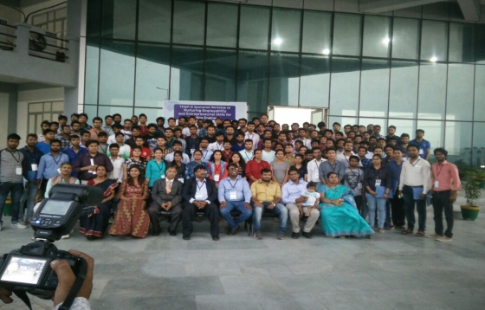**Topics covered in the workshop**:

* PRE-TEST
* Interpersonal Skills
* Communication Skills
* Presentation Skills
* Entrepreneurship Skills
* Leadership Skills
* Corporate Grooming
* 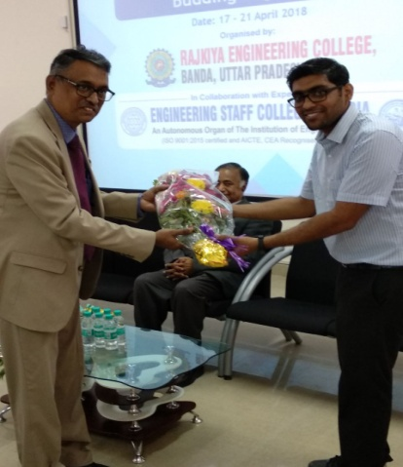Problem Solving Skills
* Aptitude and Reasoning Skills
* Emotional Intelligence
* Preparing a Brilliant CV
* Group Discussion
* Personal Interview
* POST-TEST

**Details of experts**

1. Dr. A. P. Natarajan, Visiting professor Harvard University (U.S)
2. Mr. Ashok Ram Kumar, IPR Attorney at Wordict IP, India and Fermat IP, Italy
3. Ms. Apoorva Anand Conjeevaram, Co-founder Fermat IP
4. Er. Sai Kishore .P, Head(FDP Cell), ESCI-IE(I)
5. Mr.MVD Prasad, Manager, India Bulls
6. Mrs. Prasanna, Soft Skills Trainer.
7. Dr. A. Patrick
8. Dr.  Rajpurohit Manoj Narayan Chaturvedi Shastri, SATI Vidisha
9. Mrs. Anuradha Dhara

The event is coordinated by Mr. Deep Singh Thakur, faculty coordinator start-up and Entrepreneurship cell.

**Curricular and Co-curricular Achievement**

To uplift the knowledge/ expertise level of students and faculty members tonational/international level through online courses SAWAYAM MOOCS, NPTEL (National Programme on Technology Enhanced Learning) Local Chapter has been setup at Rajkiya Engineering College Banda in February 2018 under the NPTEL Nodal centre at IIT Kanpur. The college has offered full reimbursement of fee of SWAYAM courses to the students and faculties members of the college through TEQIP-III

**Extra-Curricular Activities**



**Financial Information: Funds Received & Spent**

**State Budget**

|  |  |
| --- | --- |
| Funds Received & Spent | RUND RECEIVED: 407.41 LACS |
| EXPENDITURE: 448.48 LACS |
| Internal Revenue Generated | REVENUE RECEIVED: 411.49 LACS |
| OTHER RECEIPT:33.91 LACS |

**TEQIP-III**

**RECEIPT AND PAYMENT**

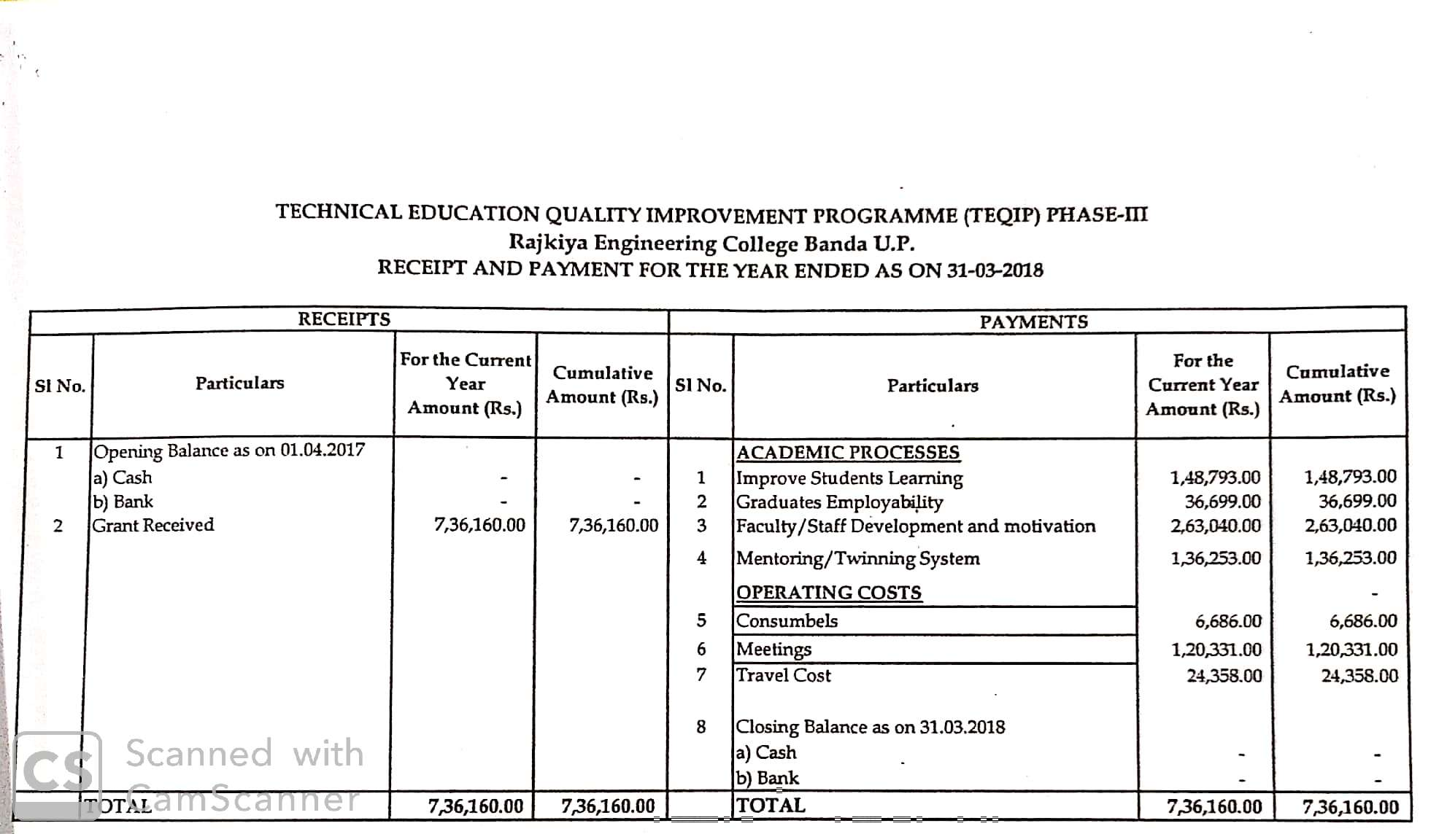

**RECONCILIATION OF CLAIMS**

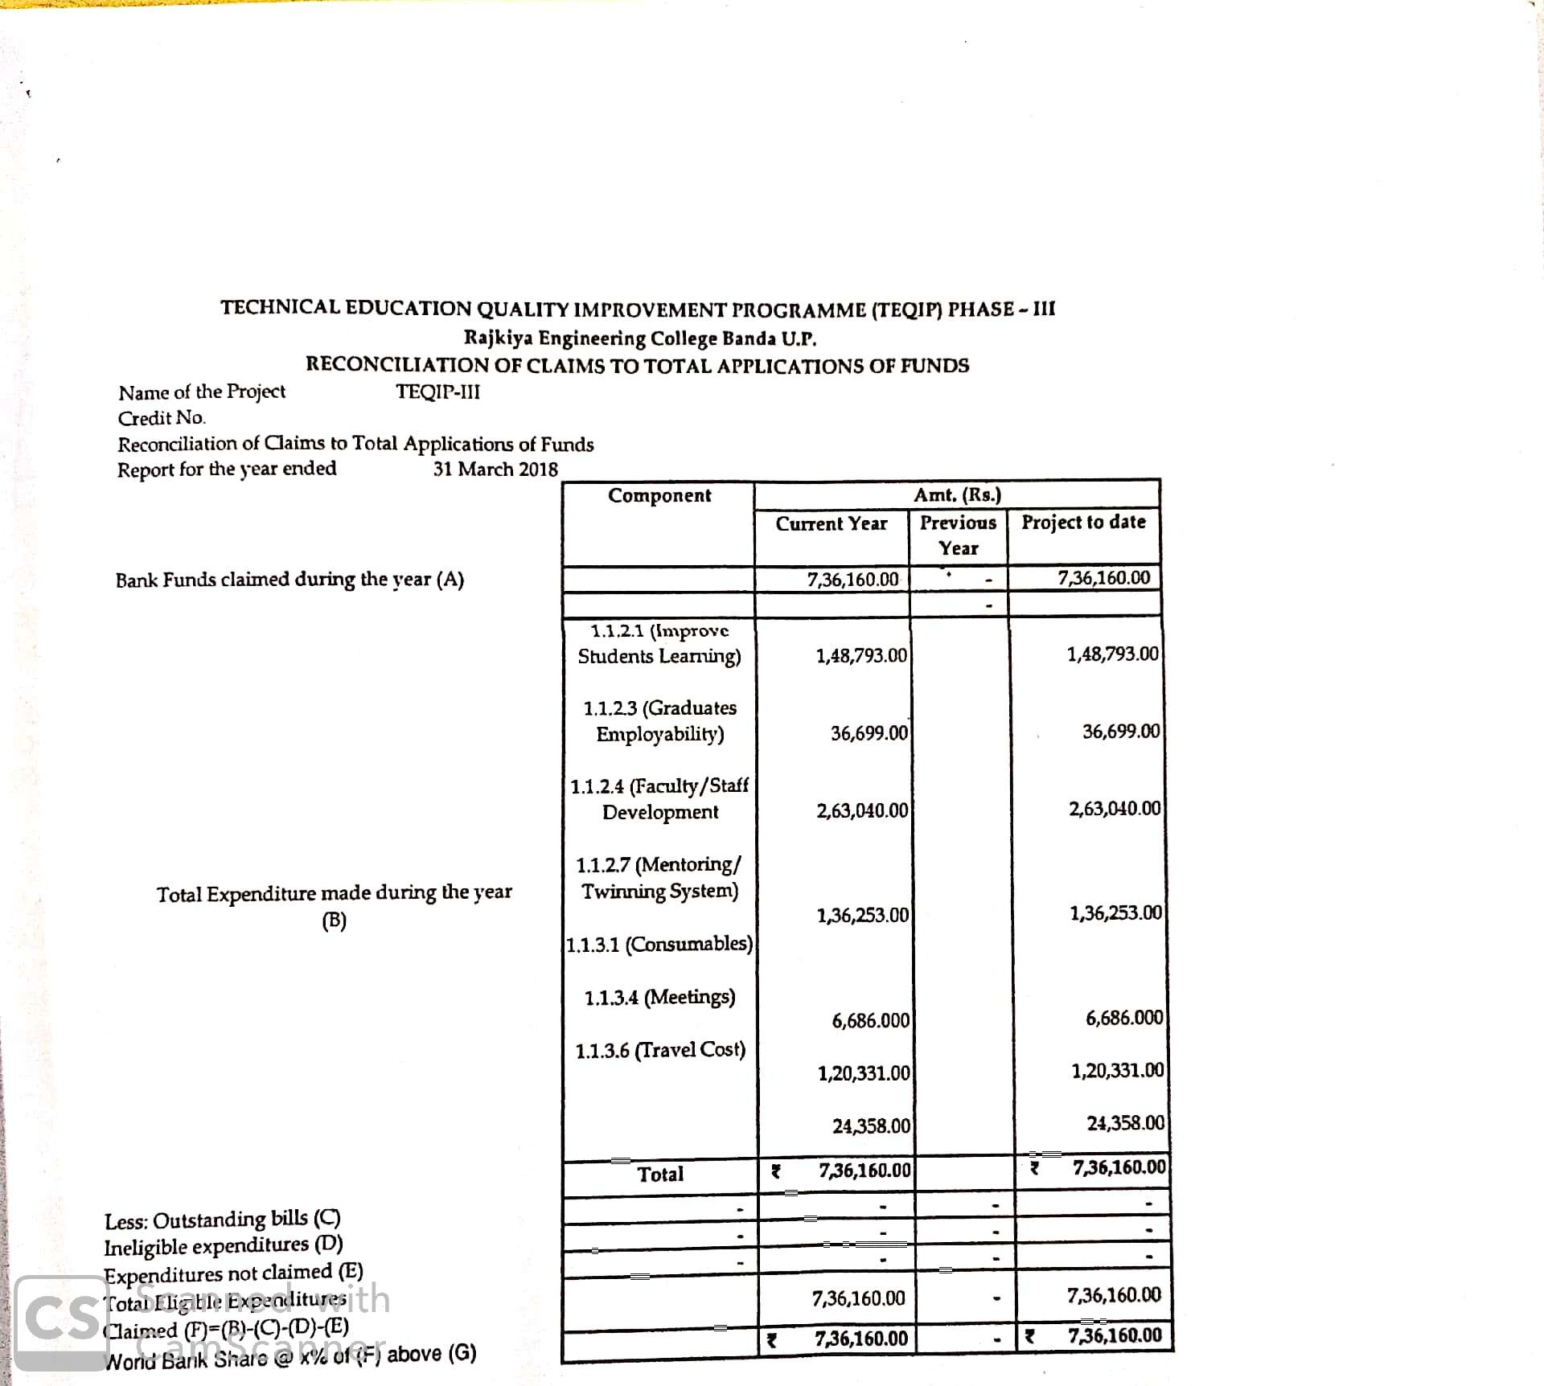

**INCOME & EXPENDITURE**

